



**Red Store E-commerce Website**

Submitted By: Shibashis Dey

Submitted To: Aman Chopra sir

Submitted On: 31/5/2022

**Acknowledgement**

I am overwhelmed in all humbleness and gratefulness to acknowledge my depth to all those who have helped me to put these ideas, well above the level of simplicity and into something concrete.I would like to express my special thanks of gratitude to my teacher **Aman Sir** as well as our mentor **Mr. Avik Ghosh** who gave me the golden opportunity to do this wonderful project on the topic **Red Store E-commerce Website**, which also helped me in doing a lot of Research and I came to know about so many new things. I am really thankful to them.I would again like to thank my teacher and mentor who helped me a lot in gathering different information, collecting data and guiding me from time to time in making this project, despite of his/her busy schedules, he/she gave me different ideas in making this project unique.

**Name:** Shibashis Dey

**College:** Kalinga Institute of Industrial Technology

**Steam:** B.Tech

**Email:** [1904286@kiit.ac.in](mailto:1904286@kiit.ac.in)

**Contact**: 8017447627

**INTRODUCTION**

Web development is the work involved in developing a website for the Internet (World Wide Web) or an Intranet (a private network). Web development can range from developing a simple single static page of plain text to complex web applications, electronic businesses, and social network services.

A more comprehensive list of tasks to which Web development commonly refers, may include Web engineering, Web design, Web content development, client liaison, client-side /server-side scripting, Web server and network security configuration, and e-commerce development.

Among Web professionals, "Web development" usually refers to the main non-design aspects of building Web sites: writing markup and coding. Web development may use content management system (CMS) to make content changes easier and available with basic technical skills.



There are two broad divisions of web development – front-end development (also called client-side development) and back-end development (also called server-side development).

Front-end development refers to constructing what a user sees when they load a web application – the content, design and how you interact with it. This is done with three codes – HTML, CSS and JavaScript.

Back-end development controls what goes on behind the scenes of a web application. A back-end often uses a database to generate the front-end.

**OBJECTIVE**

The project of the full-stack web development was done and established as a shopping cart E-commerce website with HTML, CSS, JavaScript in the Front end & PHP in the back-end to give an actual representation of the full working idea of the project.

Shopping malls and markets have been shut down due to lockdown after the pandemic that hit the world in the past few years. There has been a rise in expenses while businesses have seen major losses.  A rise in small businesses can be seen, especially after people have lost their jobs. This project was done to make shopping easy for the mass. This would help both the sellers and the consumers. The sellers can continue with their business in full swing and this would cater to the needs of the consumers as well. Keeping that in mind a web development

1. The basic front-end structure was written with HTML
2. The styling of the front-end was done with CSS.
3. JavaScript was also used to create certain functions that would make the page more responsive
4. Media queries was also used to make the page interactive with mobile screen along with the default laptop or desktop screen which is usually (16:9) in aspect ratio.

**HARDWARE AND SOFTWARE REQUIREMENTS**

**Software Required:**

Operating System: Windows/Linux

Front-end:HTML,CSS,JavaScript

Software (IDE): Notepad or VSCode

**Hardware Required:**

Speed: 233MHz and above

Hard disk: 10GB

RAM: 512 MB

**FUTURE SCOPE**

**Advantages and disadvantages**

**SNAPSHOT AND CODING**

**FOR HOME PAGE**

First we have to create the template for the HTML 5 boilerplate in which the Head section of the web-page is created and is same for all the pages.

<!DOCTYPE html>

<html lang="en">

<head>

<meta charset="UTF-8">

<meta name="viewport" content="width=device-width, initial-scale=1.0">

<meta http-equiv="X-UA-Compatible" content="IE=edge">

<meta name="viewport" content="width=device-width, initial-scale=1.0">

<title>E-commerce website</title>

<link rel="stylesheet" href="style.css">

<link rel="preconnect" href="https://fonts.googleapis.com">

<link rel="preconnect" href="https://fonts.gstatic.com" crossorigin>

<link href="https://fonts.googleapis.com/css2?family=Inconsolata:wght@300;400;500;600;700&display=swap" rel="stylesheet">

<link rel="stylesheet" href="https://cdn.jsdelivr.net/npm/@fortawesome/fontawesome-free@6.1.1/css/fontawesome.min.css" integrity="sha384-zIaWifL2YFF1qaDiAo0JFgsmasocJ/rqu7LKYH8CoBEXqGbb9eO+Xi3s6fQhgFWM" crossorigin="anonymous">

</head>

Here we linked the page to the corresponding CSS sheet,google fonts, font awsome, and bootstrap icons along with the title of the page.

**Header**

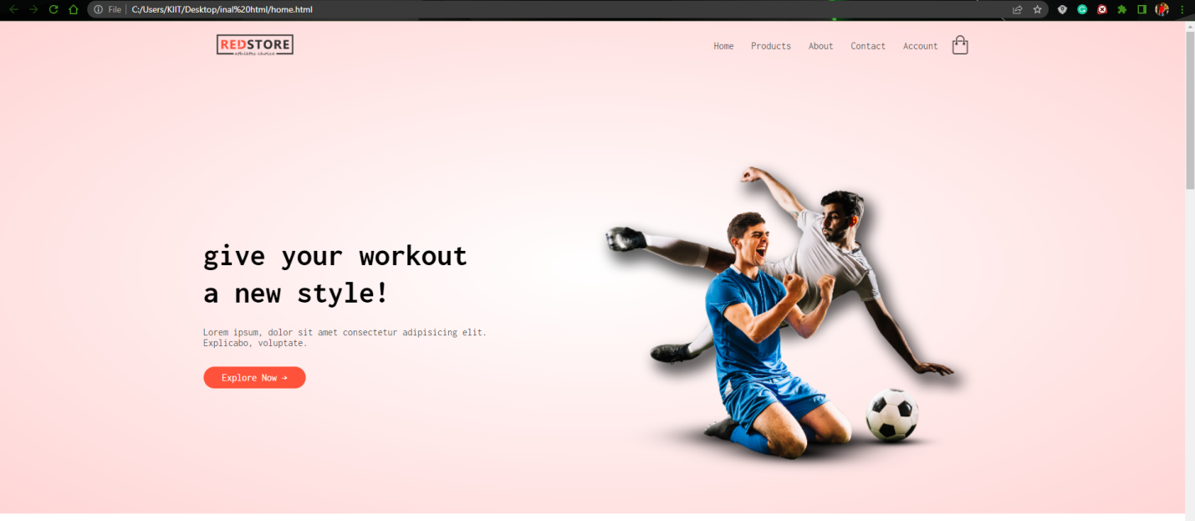

Fig 1

<div class="header">

<div class="container">

<div class="navbar">

<div class="logo">

<img src="images/logo.png" width="125px" >

</div>

<nav>

<ul id="MenuItems">

<li><a href="home.html">Home</a></li>

<li><a href="products.html">Products</a></li>

<li><a href="about.html">About</a></li>

<li><a href="contact.html">Contact</a></li>

<li><a href="account.html">Account</a></li>

</ul>

</nav>

<a href="cart.html"> <img src="images/cart.png" width="30px" height="30px"></a>

<img src="images/menu.png" class="menu-icon" onclick="menutoggle()">

</div>

<div class="row">

<div class="col-2">

<h1>give your workout <br>a new style!</h1>

<p>Success isn't always about greatness, it's about consistency. Consistent<br>hard work gains success. Greatness will come.</p>

<a href="products.html" class="btn">Explore Now &#8594;</a>

</div>

<div class="col-2">

<img src="images/image1.png">

</div>

</div>

</div>

</div>

Here we described how our naviagtion bar should look and the first view of the webpage is given here. The links to the different pages are connected here through the anchor tags. All of this was done inside a class called header class.

.navbar{

display: flex;

align-items: center;

padding: 20px;

}

nav{

flex: 1;

text-align: right;

}

nav ul{

display: inline-block;

list-style-type: none;

}

nav ul li{

display: inline-block;

margin-right: 20px;

}

a{

text-decoration: none;

color: #555;

}

p{

color: #555;

}

.container{

max-width: 1300px;

margin: auto;

padding-left: 25px;

padding-right: 25px;

}

.row{

display: flex;

align-items: center;

flex-wrap: wrap;

justify-content: space-around;

}

.col-2{

flex-basis: 50%;

min-width: 300px;

}

.col-2 img{

max-width: 100%;

padding: 50px 0;

}

.col-2 h1{

font-size: 50px;

line-height: 60px;

margin: 25px 0;

}

.btn{

display: inline-block;

background: #ff523b;

color: #fff;

padding: 8px 30px;

margin: 30px 0;

border-radius: 30px;

transition: background 0.5s;

}

.btn:hover{

background: #563434;

}

.header{

background: radial-gradient(#fff,#ffd6d6);

}

.header .row{

margin-top: 70px;

}

.catagories{

margin: 70px;

}

The entire styling of the header section was done here using the external style sheet.

**Featured Categories**

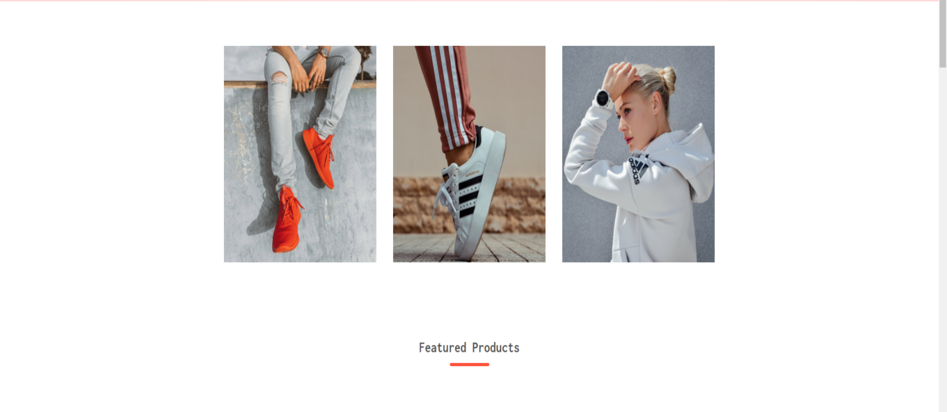Fig 2

HTML CODE:

<!--featured categories-->

<div class="catagories">

<div class="small-container">

<div class="row">

<div class="col-3">

<img src="images/category-1.jpg" >

</div>

<div class="col-3">

<img src="images/category-2.jpg" >

</div>

<div class="col-3">

<img src="images/category-3.jpg" >

</div>

</div>

</div>

</div>

The CSS code

.col-3{

flex-basis: 30%;

min-width: 250px;

margin-bottom: 30px;

}

.col-3 img{

width: 100%;

}

.small-container{

max-width: 1080px;

margin: auto;

padding-left: 25px;

padding-right: 25px;

}

**Featured products & Latest products**

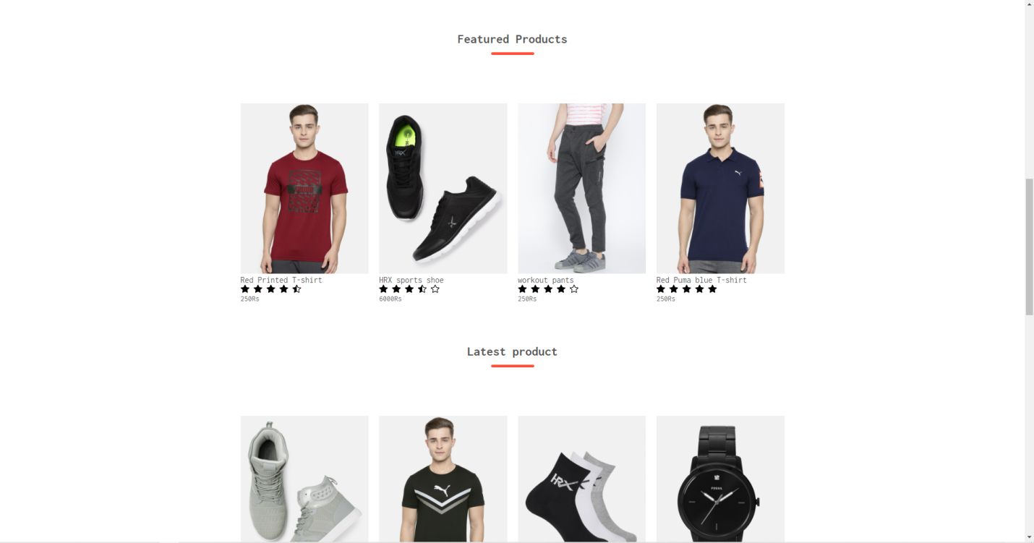

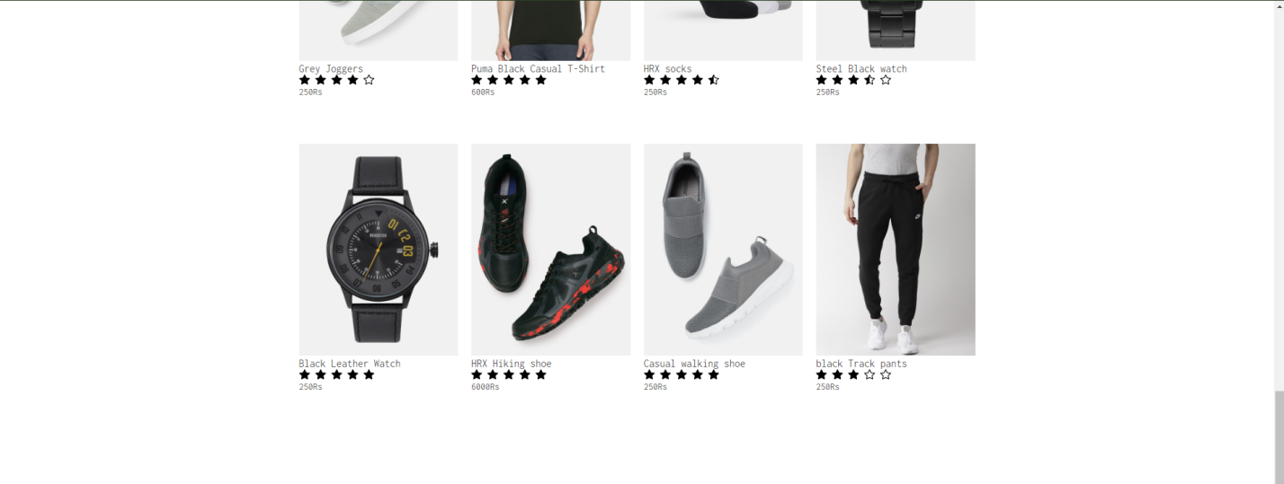

Fig 3

HTML code:

<!--featured products-->

<div class="small-container">

<h2 class="title">Featured Products</h2>

<div class="row">

<div class="col-4">

<a href="product details.html"><img src="images/product-1.jpg"></a>

<a href="product details.html"><h4>Red Printed T-shirt</h4></a>

<div class="rating">

<svg xmlns="http://www.w3.org/2000/svg" width="16" height="16" fill="currentColor" class="bi bi-star-fill" viewBox="0 0 16 16">

<path d="M3.612 15.443c-.386.198-.824-.149-.746-.592l.83-4.73L.173 6.765c-.329-.314-.158-.888.283-.95l4.898-.696L7.538.792c.197-.39.73-.39.927 0l2.184 4.327 4.898.696c.441.062.612.636.282.95l-3.522 3.356.83 4.73c.078.443-.36.79-.746.592L8 13.187l-4.389 2.256z"/>

</svg>

<svg xmlns="http://www.w3.org/2000/svg" width="16" height="16" fill="currentColor" class="bi bi-star-fill" viewBox="0 0 16 16">

<path d="M3.612 15.443c-.386.198-.824-.149-.746-.592l.83-4.73L.173 6.765c-.329-.314-.158-.888.283-.95l4.898-.696L7.538.792c.197-.39.73-.39.927 0l2.184 4.327 4.898.696c.441.062.612.636.282.95l-3.522 3.356.83 4.73c.078.443-.36.79-.746.592L8 13.187l-4.389 2.256z"/>

</svg>

<svg xmlns="http://www.w3.org/2000/svg" width="16" height="16" fill="currentColor" class="bi bi-star-fill" viewBox="0 0 16 16">

<path d="M3.612 15.443c-.386.198-.824-.149-.746-.592l.83-4.73L.173 6.765c-.329-.314-.158-.888.283-.95l4.898-.696L7.538.792c.197-.39.73-.39.927 0l2.184 4.327 4.898.696c.441.062.612.636.282.95l-3.522 3.356.83 4.73c.078.443-.36.79-.746.592L8 13.187l-4.389 2.256z"/>

</svg>

<svg xmlns="http://www.w3.org/2000/svg" width="16" height="16" fill="currentColor" class="bi bi-star-fill" viewBox="0 0 16 16">

<path d="M3.612 15.443c-.386.198-.824-.149-.746-.592l.83-4.73L.173 6.765c-.329-.314-.158-.888.283-.95l4.898-.696L7.538.792c.197-.39.73-.39.927 0l2.184 4.327 4.898.696c.441.062.612.636.282.95l-3.522 3.356.83 4.73c.078.443-.36.79-.746.592L8 13.187l-4.389 2.256z"/>

</svg>

<svg xmlns="http://www.w3.org/2000/svg" width="16" height="16" fill="currentColor" class="bi bi-star-half" viewBox="0 0 16 16">

<path d="M5.354 5.119 7.538.792A.516.516 0 0 1 8 .5c.183 0 .366.097.465.292l2.184 4.327 4.898.696A.537.537 0 0 1 16 6.32a.548.548 0 0 1-.17.445l-3.523 3.356.83 4.73c.078.443-.36.79-.746.592L8 13.187l-4.389 2.256a.52.52 0 0 1-.146.05c-.342.06-.668-.254-.6-.642l.83-4.73L.173 6.765a.55.55 0 0 1-.172-.403.58.58 0 0 1 .085-.302.513.513 0 0 1 .37-.245l4.898-.696zM8 12.027a.5.5 0 0 1 .232.056l3.686 1.894-.694-3.957a.565.565 0 0 1 .162-.505l2.907-2.77-4.052-.576a.525.525 0 0 1-.393-.288L8.001 2.223 8 2.226v9.8z"/>

</svg>

</div>

<p>250Rs</p>

</div>

<div class="col-4">

<img src="images/product-2.jpg">

<h4>HRX sports shoe</h4>

<div class="rating">

<svg xmlns="http://www.w3.org/2000/svg" width="16" height="16" fill="currentColor" class="bi bi-star-fill" viewBox="0 0 16 16">

<path d="M3.612 15.443c-.386.198-.824-.149-.746-.592l.83-4.73L.173 6.765c-.329-.314-.158-.888.283-.95l4.898-.696L7.538.792c.197-.39.73-.39.927 0l2.184 4.327 4.898.696c.441.062.612.636.282.95l-3.522 3.356.83 4.73c.078.443-.36.79-.746.592L8 13.187l-4.389 2.256z"/>

</svg>

<svg xmlns="http://www.w3.org/2000/svg" width="16" height="16" fill="currentColor" class="bi bi-star-fill" viewBox="0 0 16 16">

<path d="M3.612 15.443c-.386.198-.824-.149-.746-.592l.83-4.73L.173 6.765c-.329-.314-.158-.888.283-.95l4.898-.696L7.538.792c.197-.39.73-.39.927 0l2.184 4.327 4.898.696c.441.062.612.636.282.95l-3.522 3.356.83 4.73c.078.443-.36.79-.746.592L8 13.187l-4.389 2.256z"/>

</svg>

<svg xmlns="http://www.w3.org/2000/svg" width="16" height="16" fill="currentColor" class="bi bi-star-fill" viewBox="0 0 16 16">

<path d="M3.612 15.443c-.386.198-.824-.149-.746-.592l.83-4.73L.173 6.765c-.329-.314-.158-.888.283-.95l4.898-.696L7.538.792c.197-.39.73-.39.927 0l2.184 4.327 4.898.696c.441.062.612.636.282.95l-3.522 3.356.83 4.73c.078.443-.36.79-.746.592L8 13.187l-4.389 2.256z"/>

</svg>

<svg xmlns="http://www.w3.org/2000/svg" width="16" height="16" fill="currentColor" class="bi bi-star-half" viewBox="0 0 16 16">

<path d="M5.354 5.119 7.538.792A.516.516 0 0 1 8 .5c.183 0 .366.097.465.292l2.184 4.327 4.898.696A.537.537 0 0 1 16 6.32a.548.548 0 0 1-.17.445l-3.523 3.356.83 4.73c.078.443-.36.79-.746.592L8 13.187l-4.389 2.256a.52.52 0 0 1-.146.05c-.342.06-.668-.254-.6-.642l.83-4.73L.173 6.765a.55.55 0 0 1-.172-.403.58.58 0 0 1 .085-.302.513.513 0 0 1 .37-.245l4.898-.696zM8 12.027a.5.5 0 0 1 .232.056l3.686 1.894-.694-3.957a.565.565 0 0 1 .162-.505l2.907-2.77-4.052-.576a.525.525 0 0 1-.393-.288L8.001 2.223 8 2.226v9.8z"/>

</svg>

<svg xmlns="http://www.w3.org/2000/svg" width="16" height="16" fill="currentColor" class="bi bi-star" viewBox="0 0 16 16">

<path d="M2.866 14.85c-.078.444.36.791.746.593l4.39-2.256 4.389 2.256c.386.198.824-.149.746-.592l-.83-4.73 3.522-3.356c.33-.314.16-.888-.282-.95l-4.898-.696L8.465.792a.513.513 0 0 0-.927 0L5.354 5.12l-4.898.696c-.441.062-.612.636-.283.95l3.523 3.356-.83 4.73zm4.905-2.767-3.686 1.894.694-3.957a.565.565 0 0 0-.163-.505L1.71 6.745l4.052-.576a.525.525 0 0 0 .393-.288L8 2.223l1.847 3.658a.525.525 0 0 0 .393.288l4.052.575-2.906 2.77a.565.565 0 0 0-.163.506l.694 3.957-3.686-1.894a.503.503 0 0 0-.461 0z"/>

</svg>

</div>

<p>6000Rs</p>

</div>

<div class="col-4">

<img src="images/product-3.jpg">

<h4>workout pants</h4>

<div class="rating">

<svg xmlns="http://www.w3.org/2000/svg" width="16" height="16" fill="currentColor" class="bi bi-star-fill" viewBox="0 0 16 16">

<path d="M3.612 15.443c-.386.198-.824-.149-.746-.592l.83-4.73L.173 6.765c-.329-.314-.158-.888.283-.95l4.898-.696L7.538.792c.197-.39.73-.39.927 0l2.184 4.327 4.898.696c.441.062.612.636.282.95l-3.522 3.356.83 4.73c.078.443-.36.79-.746.592L8 13.187l-4.389 2.256z"/>

</svg>

<svg xmlns="http://www.w3.org/2000/svg" width="16" height="16" fill="currentColor" class="bi bi-star-fill" viewBox="0 0 16 16">

<path d="M3.612 15.443c-.386.198-.824-.149-.746-.592l.83-4.73L.173 6.765c-.329-.314-.158-.888.283-.95l4.898-.696L7.538.792c.197-.39.73-.39.927 0l2.184 4.327 4.898.696c.441.062.612.636.282.95l-3.522 3.356.83 4.73c.078.443-.36.79-.746.592L8 13.187l-4.389 2.256z"/>

</svg>

<svg xmlns="http://www.w3.org/2000/svg" width="16" height="16" fill="currentColor" class="bi bi-star-fill" viewBox="0 0 16 16">

<path d="M3.612 15.443c-.386.198-.824-.149-.746-.592l.83-4.73L.173 6.765c-.329-.314-.158-.888.283-.95l4.898-.696L7.538.792c.197-.39.73-.39.927 0l2.184 4.327 4.898.696c.441.062.612.636.282.95l-3.522 3.356.83 4.73c.078.443-.36.79-.746.592L8 13.187l-4.389 2.256z"/>

</svg>

<svg xmlns="http://www.w3.org/2000/svg" width="16" height="16" fill="currentColor" class="bi bi-star-fill" viewBox="0 0 16 16">

<path d="M3.612 15.443c-.386.198-.824-.149-.746-.592l.83-4.73L.173 6.765c-.329-.314-.158-.888.283-.95l4.898-.696L7.538.792c.197-.39.73-.39.927 0l2.184 4.327 4.898.696c.441.062.612.636.282.95l-3.522 3.356.83 4.73c.078.443-.36.79-.746.592L8 13.187l-4.389 2.256z"/>

</svg>

<svg xmlns="http://www.w3.org/2000/svg" width="16" height="16" fill="currentColor" class="bi bi-star" viewBox="0 0 16 16">

<path d="M2.866 14.85c-.078.444.36.791.746.593l4.39-2.256 4.389 2.256c.386.198.824-.149.746-.592l-.83-4.73 3.522-3.356c.33-.314.16-.888-.282-.95l-4.898-.696L8.465.792a.513.513 0 0 0-.927 0L5.354 5.12l-4.898.696c-.441.062-.612.636-.283.95l3.523 3.356-.83 4.73zm4.905-2.767-3.686 1.894.694-3.957a.565.565 0 0 0-.163-.505L1.71 6.745l4.052-.576a.525.525 0 0 0 .393-.288L8 2.223l1.847 3.658a.525.525 0 0 0 .393.288l4.052.575-2.906 2.77a.565.565 0 0 0-.163.506l.694 3.957-3.686-1.894a.503.503 0 0 0-.461 0z"/>

</svg>

</div>

<p>250Rs</p>

</div>

<div class="col-4">

<img src="images/product-4.jpg">

<h4>Red Puma blue T-shirt</h4>

<div class="rating">

<svg xmlns="http://www.w3.org/2000/svg" width="16" height="16" fill="currentColor" class="bi bi-star-fill" viewBox="0 0 16 16">

<path d="M3.612 15.443c-.386.198-.824-.149-.746-.592l.83-4.73L.173 6.765c-.329-.314-.158-.888.283-.95l4.898-.696L7.538.792c.197-.39.73-.39.927 0l2.184 4.327 4.898.696c.441.062.612.636.282.95l-3.522 3.356.83 4.73c.078.443-.36.79-.746.592L8 13.187l-4.389 2.256z"/>

</svg>

<svg xmlns="http://www.w3.org/2000/svg" width="16" height="16" fill="currentColor" class="bi bi-star-fill" viewBox="0 0 16 16">

<path d="M3.612 15.443c-.386.198-.824-.149-.746-.592l.83-4.73L.173 6.765c-.329-.314-.158-.888.283-.95l4.898-.696L7.538.792c.197-.39.73-.39.927 0l2.184 4.327 4.898.696c.441.062.612.636.282.95l-3.522 3.356.83 4.73c.078.443-.36.79-.746.592L8 13.187l-4.389 2.256z"/>

</svg>

<svg xmlns="http://www.w3.org/2000/svg" width="16" height="16" fill="currentColor" class="bi bi-star-fill" viewBox="0 0 16 16">

<path d="M3.612 15.443c-.386.198-.824-.149-.746-.592l.83-4.73L.173 6.765c-.329-.314-.158-.888.283-.95l4.898-.696L7.538.792c.197-.39.73-.39.927 0l2.184 4.327 4.898.696c.441.062.612.636.282.95l-3.522 3.356.83 4.73c.078.443-.36.79-.746.592L8 13.187l-4.389 2.256z"/>

</svg>

<svg xmlns="http://www.w3.org/2000/svg" width="16" height="16" fill="currentColor" class="bi bi-star-fill" viewBox="0 0 16 16">

<path d="M3.612 15.443c-.386.198-.824-.149-.746-.592l.83-4.73L.173 6.765c-.329-.314-.158-.888.283-.95l4.898-.696L7.538.792c.197-.39.73-.39.927 0l2.184 4.327 4.898.696c.441.062.612.636.282.95l-3.522 3.356.83 4.73c.078.443-.36.79-.746.592L8 13.187l-4.389 2.256z"/>

</svg>

<svg xmlns="http://www.w3.org/2000/svg" width="16" height="16" fill="currentColor" class="bi bi-star-fill" viewBox="0 0 16 16">

<path d="M3.612 15.443c-.386.198-.824-.149-.746-.592l.83-4.73L.173 6.765c-.329-.314-.158-.888.283-.95l4.898-.696L7.538.792c.197-.39.73-.39.927 0l2.184 4.327 4.898.696c.441.062.612.636.282.95l-3.522 3.356.83 4.73c.078.443-.36.79-.746.592L8 13.187l-4.389 2.256z"/>

</svg>

</div>

<p>250Rs</p>

</div>

</div>

<h2 class="title">Latest product</h2>

<div class="row">

<div class="col-4">

<img src="images/product-5.jpg">

<h4>Grey Joggers</h4>

<div class="rating">

<svg xmlns="http://www.w3.org/2000/svg" width="16" height="16" fill="currentColor" class="bi bi-star-fill" viewBox="0 0 16 16">

<path d="M3.612 15.443c-.386.198-.824-.149-.746-.592l.83-4.73L.173 6.765c-.329-.314-.158-.888.283-.95l4.898-.696L7.538.792c.197-.39.73-.39.927 0l2.184 4.327 4.898.696c.441.062.612.636.282.95l-3.522 3.356.83 4.73c.078.443-.36.79-.746.592L8 13.187l-4.389 2.256z"/>

</svg>

<svg xmlns="http://www.w3.org/2000/svg" width="16" height="16" fill="currentColor" class="bi bi-star-fill" viewBox="0 0 16 16">

<path d="M3.612 15.443c-.386.198-.824-.149-.746-.592l.83-4.73L.173 6.765c-.329-.314-.158-.888.283-.95l4.898-.696L7.538.792c.197-.39.73-.39.927 0l2.184 4.327 4.898.696c.441.062.612.636.282.95l-3.522 3.356.83 4.73c.078.443-.36.79-.746.592L8 13.187l-4.389 2.256z"/>

</svg>

<svg xmlns="http://www.w3.org/2000/svg" width="16" height="16" fill="currentColor" class="bi bi-star-fill" viewBox="0 0 16 16">

<path d="M3.612 15.443c-.386.198-.824-.149-.746-.592l.83-4.73L.173 6.765c-.329-.314-.158-.888.283-.95l4.898-.696L7.538.792c.197-.39.73-.39.927 0l2.184 4.327 4.898.696c.441.062.612.636.282.95l-3.522 3.356.83 4.73c.078.443-.36.79-.746.592L8 13.187l-4.389 2.256z"/>

</svg>

<svg xmlns="http://www.w3.org/2000/svg" width="16" height="16" fill="currentColor" class="bi bi-star-fill" viewBox="0 0 16 16">

<path d="M3.612 15.443c-.386.198-.824-.149-.746-.592l.83-4.73L.173 6.765c-.329-.314-.158-.888.283-.95l4.898-.696L7.538.792c.197-.39.73-.39.927 0l2.184 4.327 4.898.696c.441.062.612.636.282.95l-3.522 3.356.83 4.73c.078.443-.36.79-.746.592L8 13.187l-4.389 2.256z"/>

</svg>

<svg xmlns="http://www.w3.org/2000/svg" width="16" height="16" fill="currentColor" class="bi bi-star" viewBox="0 0 16 16">

<path d="M2.866 14.85c-.078.444.36.791.746.593l4.39-2.256 4.389 2.256c.386.198.824-.149.746-.592l-.83-4.73 3.522-3.356c.33-.314.16-.888-.282-.95l-4.898-.696L8.465.792a.513.513 0 0 0-.927 0L5.354 5.12l-4.898.696c-.441.062-.612.636-.283.95l3.523 3.356-.83 4.73zm4.905-2.767-3.686 1.894.694-3.957a.565.565 0 0 0-.163-.505L1.71 6.745l4.052-.576a.525.525 0 0 0 .393-.288L8 2.223l1.847 3.658a.525.525 0 0 0 .393.288l4.052.575-2.906 2.77a.565.565 0 0 0-.163.506l.694 3.957-3.686-1.894a.503.503 0 0 0-.461 0z"/>

</svg>

</div>

<p>250Rs</p>

</div>

<div class="col-4">

<img src="images/product-6.jpg">

<h4>Puma Black Casual T-Shirt </h4>

<div class="rating">

<svg xmlns="http://www.w3.org/2000/svg" width="16" height="16" fill="currentColor" class="bi bi-star-fill" viewBox="0 0 16 16">

<path d="M3.612 15.443c-.386.198-.824-.149-.746-.592l.83-4.73L.173 6.765c-.329-.314-.158-.888.283-.95l4.898-.696L7.538.792c.197-.39.73-.39.927 0l2.184 4.327 4.898.696c.441.062.612.636.282.95l-3.522 3.356.83 4.73c.078.443-.36.79-.746.592L8 13.187l-4.389 2.256z"/>

</svg>

<svg xmlns="http://www.w3.org/2000/svg" width="16" height="16" fill="currentColor" class="bi bi-star-fill" viewBox="0 0 16 16">

<path d="M3.612 15.443c-.386.198-.824-.149-.746-.592l.83-4.73L.173 6.765c-.329-.314-.158-.888.283-.95l4.898-.696L7.538.792c.197-.39.73-.39.927 0l2.184 4.327 4.898.696c.441.062.612.636.282.95l-3.522 3.356.83 4.73c.078.443-.36.79-.746.592L8 13.187l-4.389 2.256z"/>

</svg>

<svg xmlns="http://www.w3.org/2000/svg" width="16" height="16" fill="currentColor" class="bi bi-star-fill" viewBox="0 0 16 16">

<path d="M3.612 15.443c-.386.198-.824-.149-.746-.592l.83-4.73L.173 6.765c-.329-.314-.158-.888.283-.95l4.898-.696L7.538.792c.197-.39.73-.39.927 0l2.184 4.327 4.898.696c.441.062.612.636.282.95l-3.522 3.356.83 4.73c.078.443-.36.79-.746.592L8 13.187l-4.389 2.256z"/>

</svg>

<svg xmlns="http://www.w3.org/2000/svg" width="16" height="16" fill="currentColor" class="bi bi-star-fill" viewBox="0 0 16 16">

<path d="M3.612 15.443c-.386.198-.824-.149-.746-.592l.83-4.73L.173 6.765c-.329-.314-.158-.888.283-.95l4.898-.696L7.538.792c.197-.39.73-.39.927 0l2.184 4.327 4.898.696c.441.062.612.636.282.95l-3.522 3.356.83 4.73c.078.443-.36.79-.746.592L8 13.187l-4.389 2.256z"/>

</svg>

<svg xmlns="http://www.w3.org/2000/svg" width="16" height="16" fill="currentColor" class="bi bi-star-fill" viewBox="0 0 16 16">

<path d="M3.612 15.443c-.386.198-.824-.149-.746-.592l.83-4.73L.173 6.765c-.329-.314-.158-.888.283-.95l4.898-.696L7.538.792c.197-.39.73-.39.927 0l2.184 4.327 4.898.696c.441.062.612.636.282.95l-3.522 3.356.83 4.73c.078.443-.36.79-.746.592L8 13.187l-4.389 2.256z"/>

</svg>

</div>

<p>600Rs</p>

</div>

<div class="col-4">

<img src="images/product-7.jpg">

<h4>HRX socks</h4>

<div class="rating">

<svg xmlns="http://www.w3.org/2000/svg" width="16" height="16" fill="currentColor" class="bi bi-star-fill" viewBox="0 0 16 16">

<path d="M3.612 15.443c-.386.198-.824-.149-.746-.592l.83-4.73L.173 6.765c-.329-.314-.158-.888.283-.95l4.898-.696L7.538.792c.197-.39.73-.39.927 0l2.184 4.327 4.898.696c.441.062.612.636.282.95l-3.522 3.356.83 4.73c.078.443-.36.79-.746.592L8 13.187l-4.389 2.256z"/>

</svg>

<svg xmlns="http://www.w3.org/2000/svg" width="16" height="16" fill="currentColor" class="bi bi-star-fill" viewBox="0 0 16 16">

<path d="M3.612 15.443c-.386.198-.824-.149-.746-.592l.83-4.73L.173 6.765c-.329-.314-.158-.888.283-.95l4.898-.696L7.538.792c.197-.39.73-.39.927 0l2.184 4.327 4.898.696c.441.062.612.636.282.95l-3.522 3.356.83 4.73c.078.443-.36.79-.746.592L8 13.187l-4.389 2.256z"/>

</svg>

<svg xmlns="http://www.w3.org/2000/svg" width="16" height="16" fill="currentColor" class="bi bi-star-fill" viewBox="0 0 16 16">

<path d="M3.612 15.443c-.386.198-.824-.149-.746-.592l.83-4.73L.173 6.765c-.329-.314-.158-.888.283-.95l4.898-.696L7.538.792c.197-.39.73-.39.927 0l2.184 4.327 4.898.696c.441.062.612.636.282.95l-3.522 3.356.83 4.73c.078.443-.36.79-.746.592L8 13.187l-4.389 2.256z"/>

</svg>

<svg xmlns="http://www.w3.org/2000/svg" width="16" height="16" fill="currentColor" class="bi bi-star-fill" viewBox="0 0 16 16">

<path d="M3.612 15.443c-.386.198-.824-.149-.746-.592l.83-4.73L.173 6.765c-.329-.314-.158-.888.283-.95l4.898-.696L7.538.792c.197-.39.73-.39.927 0l2.184 4.327 4.898.696c.441.062.612.636.282.95l-3.522 3.356.83 4.73c.078.443-.36.79-.746.592L8 13.187l-4.389 2.256z"/>

</svg>

<svg xmlns="http://www.w3.org/2000/svg" width="16" height="16" fill="currentColor" class="bi bi-star-half" viewBox="0 0 16 16">

<path d="M5.354 5.119 7.538.792A.516.516 0 0 1 8 .5c.183 0 .366.097.465.292l2.184 4.327 4.898.696A.537.537 0 0 1 16 6.32a.548.548 0 0 1-.17.445l-3.523 3.356.83 4.73c.078.443-.36.79-.746.592L8 13.187l-4.389 2.256a.52.52 0 0 1-.146.05c-.342.06-.668-.254-.6-.642l.83-4.73L.173 6.765a.55.55 0 0 1-.172-.403.58.58 0 0 1 .085-.302.513.513 0 0 1 .37-.245l4.898-.696zM8 12.027a.5.5 0 0 1 .232.056l3.686 1.894-.694-3.957a.565.565 0 0 1 .162-.505l2.907-2.77-4.052-.576a.525.525 0 0 1-.393-.288L8.001 2.223 8 2.226v9.8z"/>

</svg>

</div>

<p>250Rs</p>

</div>

<div class="col-4">

<img src="images/product-8.jpg">

<h4>Steel Black watch</h4>

<div class="rating">

<svg xmlns="http://www.w3.org/2000/svg" width="16" height="16" fill="currentColor" class="bi bi-star-fill" viewBox="0 0 16 16">

<path d="M3.612 15.443c-.386.198-.824-.149-.746-.592l.83-4.73L.173 6.765c-.329-.314-.158-.888.283-.95l4.898-.696L7.538.792c.197-.39.73-.39.927 0l2.184 4.327 4.898.696c.441.062.612.636.282.95l-3.522 3.356.83 4.73c.078.443-.36.79-.746.592L8 13.187l-4.389 2.256z"/>

</svg>

<svg xmlns="http://www.w3.org/2000/svg" width="16" height="16" fill="currentColor" class="bi bi-star-fill" viewBox="0 0 16 16">

<path d="M3.612 15.443c-.386.198-.824-.149-.746-.592l.83-4.73L.173 6.765c-.329-.314-.158-.888.283-.95l4.898-.696L7.538.792c.197-.39.73-.39.927 0l2.184 4.327 4.898.696c.441.062.612.636.282.95l-3.522 3.356.83 4.73c.078.443-.36.79-.746.592L8 13.187l-4.389 2.256z"/>

</svg>

<svg xmlns="http://www.w3.org/2000/svg" width="16" height="16" fill="currentColor" class="bi bi-star-fill" viewBox="0 0 16 16">

<path d="M3.612 15.443c-.386.198-.824-.149-.746-.592l.83-4.73L.173 6.765c-.329-.314-.158-.888.283-.95l4.898-.696L7.538.792c.197-.39.73-.39.927 0l2.184 4.327 4.898.696c.441.062.612.636.282.95l-3.522 3.356.83 4.73c.078.443-.36.79-.746.592L8 13.187l-4.389 2.256z"/>

</svg>

<svg xmlns="http://www.w3.org/2000/svg" width="16" height="16" fill="currentColor" class="bi bi-star-half" viewBox="0 0 16 16">

<path d="M5.354 5.119 7.538.792A.516.516 0 0 1 8 .5c.183 0 .366.097.465.292l2.184 4.327 4.898.696A.537.537 0 0 1 16 6.32a.548.548 0 0 1-.17.445l-3.523 3.356.83 4.73c.078.443-.36.79-.746.592L8 13.187l-4.389 2.256a.52.52 0 0 1-.146.05c-.342.06-.668-.254-.6-.642l.83-4.73L.173 6.765a.55.55 0 0 1-.172-.403.58.58 0 0 1 .085-.302.513.513 0 0 1 .37-.245l4.898-.696zM8 12.027a.5.5 0 0 1 .232.056l3.686 1.894-.694-3.957a.565.565 0 0 1 .162-.505l2.907-2.77-4.052-.576a.525.525 0 0 1-.393-.288L8.001 2.223 8 2.226v9.8z"/>

</svg>

<svg xmlns="http://www.w3.org/2000/svg" width="16" height="16" fill="currentColor" class="bi bi-star" viewBox="0 0 16 16">

<path d="M2.866 14.85c-.078.444.36.791.746.593l4.39-2.256 4.389 2.256c.386.198.824-.149.746-.592l-.83-4.73 3.522-3.356c.33-.314.16-.888-.282-.95l-4.898-.696L8.465.792a.513.513 0 0 0-.927 0L5.354 5.12l-4.898.696c-.441.062-.612.636-.283.95l3.523 3.356-.83 4.73zm4.905-2.767-3.686 1.894.694-3.957a.565.565 0 0 0-.163-.505L1.71 6.745l4.052-.576a.525.525 0 0 0 .393-.288L8 2.223l1.847 3.658a.525.525 0 0 0 .393.288l4.052.575-2.906 2.77a.565.565 0 0 0-.163.506l.694 3.957-3.686-1.894a.503.503 0 0 0-.461 0z"/>

</svg>

</div>

<p>250Rs</p>

</div>

</div>

<div class="row">

<div class="col-4">

<img src="images/product-9.jpg">

<h4>Black Leather Watch</h4>

<div class="rating">

<svg xmlns="http://www.w3.org/2000/svg" width="16" height="16" fill="currentColor" class="bi bi-star-fill" viewBox="0 0 16 16">

<path d="M3.612 15.443c-.386.198-.824-.149-.746-.592l.83-4.73L.173 6.765c-.329-.314-.158-.888.283-.95l4.898-.696L7.538.792c.197-.39.73-.39.927 0l2.184 4.327 4.898.696c.441.062.612.636.282.95l-3.522 3.356.83 4.73c.078.443-.36.79-.746.592L8 13.187l-4.389 2.256z"/>

</svg>

<svg xmlns="http://www.w3.org/2000/svg" width="16" height="16" fill="currentColor" class="bi bi-star-fill" viewBox="0 0 16 16">

<path d="M3.612 15.443c-.386.198-.824-.149-.746-.592l.83-4.73L.173 6.765c-.329-.314-.158-.888.283-.95l4.898-.696L7.538.792c.197-.39.73-.39.927 0l2.184 4.327 4.898.696c.441.062.612.636.282.95l-3.522 3.356.83 4.73c.078.443-.36.79-.746.592L8 13.187l-4.389 2.256z"/>

</svg>

<svg xmlns="http://www.w3.org/2000/svg" width="16" height="16" fill="currentColor" class="bi bi-star-fill" viewBox="0 0 16 16">

<path d="M3.612 15.443c-.386.198-.824-.149-.746-.592l.83-4.73L.173 6.765c-.329-.314-.158-.888.283-.95l4.898-.696L7.538.792c.197-.39.73-.39.927 0l2.184 4.327 4.898.696c.441.062.612.636.282.95l-3.522 3.356.83 4.73c.078.443-.36.79-.746.592L8 13.187l-4.389 2.256z"/>

</svg>

<svg xmlns="http://www.w3.org/2000/svg" width="16" height="16" fill="currentColor" class="bi bi-star-fill" viewBox="0 0 16 16">

<path d="M3.612 15.443c-.386.198-.824-.149-.746-.592l.83-4.73L.173 6.765c-.329-.314-.158-.888.283-.95l4.898-.696L7.538.792c.197-.39.73-.39.927 0l2.184 4.327 4.898.696c.441.062.612.636.282.95l-3.522 3.356.83 4.73c.078.443-.36.79-.746.592L8 13.187l-4.389 2.256z"/>

</svg>

<svg xmlns="http://www.w3.org/2000/svg" width="16" height="16" fill="currentColor" class="bi bi-star-fill" viewBox="0 0 16 16">

<path d="M3.612 15.443c-.386.198-.824-.149-.746-.592l.83-4.73L.173 6.765c-.329-.314-.158-.888.283-.95l4.898-.696L7.538.792c.197-.39.73-.39.927 0l2.184 4.327 4.898.696c.441.062.612.636.282.95l-3.522 3.356.83 4.73c.078.443-.36.79-.746.592L8 13.187l-4.389 2.256z"/>

</svg>

</div>

<p>250Rs</p>

</div>

<div class="col-4">

<img src="images/product-10.jpg">

<h4>HRX Hiking shoe</h4>

<div class="rating">

<svg xmlns="http://www.w3.org/2000/svg" width="16" height="16" fill="currentColor" class="bi bi-star-fill" viewBox="0 0 16 16">

<path d="M3.612 15.443c-.386.198-.824-.149-.746-.592l.83-4.73L.173 6.765c-.329-.314-.158-.888.283-.95l4.898-.696L7.538.792c.197-.39.73-.39.927 0l2.184 4.327 4.898.696c.441.062.612.636.282.95l-3.522 3.356.83 4.73c.078.443-.36.79-.746.592L8 13.187l-4.389 2.256z"/>

</svg>

<svg xmlns="http://www.w3.org/2000/svg" width="16" height="16" fill="currentColor" class="bi bi-star-fill" viewBox="0 0 16 16">

<path d="M3.612 15.443c-.386.198-.824-.149-.746-.592l.83-4.73L.173 6.765c-.329-.314-.158-.888.283-.95l4.898-.696L7.538.792c.197-.39.73-.39.927 0l2.184 4.327 4.898.696c.441.062.612.636.282.95l-3.522 3.356.83 4.73c.078.443-.36.79-.746.592L8 13.187l-4.389 2.256z"/>

</svg>

<svg xmlns="http://www.w3.org/2000/svg" width="16" height="16" fill="currentColor" class="bi bi-star-fill" viewBox="0 0 16 16">

<path d="M3.612 15.443c-.386.198-.824-.149-.746-.592l.83-4.73L.173 6.765c-.329-.314-.158-.888.283-.95l4.898-.696L7.538.792c.197-.39.73-.39.927 0l2.184 4.327 4.898.696c.441.062.612.636.282.95l-3.522 3.356.83 4.73c.078.443-.36.79-.746.592L8 13.187l-4.389 2.256z"/>

</svg>

<svg xmlns="http://www.w3.org/2000/svg" width="16" height="16" fill="currentColor" class="bi bi-star-fill" viewBox="0 0 16 16">

<path d="M3.612 15.443c-.386.198-.824-.149-.746-.592l.83-4.73L.173 6.765c-.329-.314-.158-.888.283-.95l4.898-.696L7.538.792c.197-.39.73-.39.927 0l2.184 4.327 4.898.696c.441.062.612.636.282.95l-3.522 3.356.83 4.73c.078.443-.36.79-.746.592L8 13.187l-4.389 2.256z"/>

</svg>

<svg xmlns="http://www.w3.org/2000/svg" width="16" height="16" fill="currentColor" class="bi bi-star-fill" viewBox="0 0 16 16">

<path d="M3.612 15.443c-.386.198-.824-.149-.746-.592l.83-4.73L.173 6.765c-.329-.314-.158-.888.283-.95l4.898-.696L7.538.792c.197-.39.73-.39.927 0l2.184 4.327 4.898.696c.441.062.612.636.282.95l-3.522 3.356.83 4.73c.078.443-.36.79-.746.592L8 13.187l-4.389 2.256z"/>

</svg>

</div>

<p>6000Rs</p>

</div>

<div class="col-4">

<img src="images/product-11.jpg">

<h4>Casual walking shoe</h4>

<div class="rating">

<svg xmlns="http://www.w3.org/2000/svg" width="16" height="16" fill="currentColor" class="bi bi-star-fill" viewBox="0 0 16 16">

<path d="M3.612 15.443c-.386.198-.824-.149-.746-.592l.83-4.73L.173 6.765c-.329-.314-.158-.888.283-.95l4.898-.696L7.538.792c.197-.39.73-.39.927 0l2.184 4.327 4.898.696c.441.062.612.636.282.95l-3.522 3.356.83 4.73c.078.443-.36.79-.746.592L8 13.187l-4.389 2.256z"/>

</svg>

<svg xmlns="http://www.w3.org/2000/svg" width="16" height="16" fill="currentColor" class="bi bi-star-fill" viewBox="0 0 16 16">

<path d="M3.612 15.443c-.386.198-.824-.149-.746-.592l.83-4.73L.173 6.765c-.329-.314-.158-.888.283-.95l4.898-.696L7.538.792c.197-.39.73-.39.927 0l2.184 4.327 4.898.696c.441.062.612.636.282.95l-3.522 3.356.83 4.73c.078.443-.36.79-.746.592L8 13.187l-4.389 2.256z"/>

</svg>

<svg xmlns="http://www.w3.org/2000/svg" width="16" height="16" fill="currentColor" class="bi bi-star-fill" viewBox="0 0 16 16">

<path d="M3.612 15.443c-.386.198-.824-.149-.746-.592l.83-4.73L.173 6.765c-.329-.314-.158-.888.283-.95l4.898-.696L7.538.792c.197-.39.73-.39.927 0l2.184 4.327 4.898.696c.441.062.612.636.282.95l-3.522 3.356.83 4.73c.078.443-.36.79-.746.592L8 13.187l-4.389 2.256z"/>

</svg>

<svg xmlns="http://www.w3.org/2000/svg" width="16" height="16" fill="currentColor" class="bi bi-star-fill" viewBox="0 0 16 16">

<path d="M3.612 15.443c-.386.198-.824-.149-.746-.592l.83-4.73L.173 6.765c-.329-.314-.158-.888.283-.95l4.898-.696L7.538.792c.197-.39.73-.39.927 0l2.184 4.327 4.898.696c.441.062.612.636.282.95l-3.522 3.356.83 4.73c.078.443-.36.79-.746.592L8 13.187l-4.389 2.256z"/>

</svg>

<svg xmlns="http://www.w3.org/2000/svg" width="16" height="16" fill="currentColor" class="bi bi-star-fill" viewBox="0 0 16 16">

<path d="M3.612 15.443c-.386.198-.824-.149-.746-.592l.83-4.73L.173 6.765c-.329-.314-.158-.888.283-.95l4.898-.696L7.538.792c.197-.39.73-.39.927 0l2.184 4.327 4.898.696c.441.062.612.636.282.95l-3.522 3.356.83 4.73c.078.443-.36.79-.746.592L8 13.187l-4.389 2.256z"/>

</svg>

</div>

<p>250Rs</p>

</div>

<div class="col-4">

<img src="images/product-12.jpg">

<h4>black Track pants</h4>

<div class="rating">

<svg xmlns="http://www.w3.org/2000/svg" width="16" height="16" fill="currentColor" class="bi bi-star-fill" viewBox="0 0 16 16">

<path d="M3.612 15.443c-.386.198-.824-.149-.746-.592l.83-4.73L.173 6.765c-.329-.314-.158-.888.283-.95l4.898-.696L7.538.792c.197-.39.73-.39.927 0l2.184 4.327 4.898.696c.441.062.612.636.282.95l-3.522 3.356.83 4.73c.078.443-.36.79-.746.592L8 13.187l-4.389 2.256z"/>

</svg>

<svg xmlns="http://www.w3.org/2000/svg" width="16" height="16" fill="currentColor" class="bi bi-star-fill" viewBox="0 0 16 16">

<path d="M3.612 15.443c-.386.198-.824-.149-.746-.592l.83-4.73L.173 6.765c-.329-.314-.158-.888.283-.95l4.898-.696L7.538.792c.197-.39.73-.39.927 0l2.184 4.327 4.898.696c.441.062.612.636.282.95l-3.522 3.356.83 4.73c.078.443-.36.79-.746.592L8 13.187l-4.389 2.256z"/>

</svg>

<svg xmlns="http://www.w3.org/2000/svg" width="16" height="16" fill="currentColor" class="bi bi-star-fill" viewBox="0 0 16 16">

<path d="M3.612 15.443c-.386.198-.824-.149-.746-.592l.83-4.73L.173 6.765c-.329-.314-.158-.888.283-.95l4.898-.696L7.538.792c.197-.39.73-.39.927 0l2.184 4.327 4.898.696c.441.062.612.636.282.95l-3.522 3.356.83 4.73c.078.443-.36.79-.746.592L8 13.187l-4.389 2.256z"/>

</svg>

<svg xmlns="http://www.w3.org/2000/svg" width="16" height="16" fill="currentColor" class="bi bi-star" viewBox="0 0 16 16">

<path d="M2.866 14.85c-.078.444.36.791.746.593l4.39-2.256 4.389 2.256c.386.198.824-.149.746-.592l-.83-4.73 3.522-3.356c.33-.314.16-.888-.282-.95l-4.898-.696L8.465.792a.513.513 0 0 0-.927 0L5.354 5.12l-4.898.696c-.441.062-.612.636-.283.95l3.523 3.356-.83 4.73zm4.905-2.767-3.686 1.894.694-3.957a.565.565 0 0 0-.163-.505L1.71 6.745l4.052-.576a.525.525 0 0 0 .393-.288L8 2.223l1.847 3.658a.525.525 0 0 0 .393.288l4.052.575-2.906 2.77a.565.565 0 0 0-.163.506l.694 3.957-3.686-1.894a.503.503 0 0 0-.461 0z"/>

</svg>

<svg xmlns="http://www.w3.org/2000/svg" width="16" height="16" fill="currentColor" class="bi bi-star" viewBox="0 0 16 16">

<path d="M2.866 14.85c-.078.444.36.791.746.593l4.39-2.256 4.389 2.256c.386.198.824-.149.746-.592l-.83-4.73 3.522-3.356c.33-.314.16-.888-.282-.95l-4.898-.696L8.465.792a.513.513 0 0 0-.927 0L5.354 5.12l-4.898.696c-.441.062-.612.636-.283.95l3.523 3.356-.83 4.73zm4.905-2.767-3.686 1.894.694-3.957a.565.565 0 0 0-.163-.505L1.71 6.745l4.052-.576a.525.525 0 0 0 .393-.288L8 2.223l1.847 3.658a.525.525 0 0 0 .393.288l4.052.575-2.906 2.77a.565.565 0 0 0-.163.506l.694 3.957-3.686-1.894a.503.503 0 0 0-.461 0z"/>

</svg>

</div>

<p>250Rs</p>

</div>

</div>

</div>

Here the featured products were displayed and was available to buy from. Hover effects were also added to the products images to make the web-page more user interactive and the products are connected to the product details where it is to be viewed in details.

**CSS CODE:**

.col-4{

flex-basis: 25%;

padding: 10px;

min-width: 200px;

margin-bottom: 50px;

transition: transform 0.25s;

}

.col-4 img{

width: 100%;

}

.title{

text-align: center;

margin: 0 auto 80px;

position: relative;

line-height: 60px;

color: #555;

}

.title::after{

content: '';

background: #ff523b;

width: 80px;

height: 5px;

border-radius: 5px;

position: absolute;

bottom: 0;

left: 50%;

transform: translateX(-50%);

}

h4{

color: #555;

font-weight: normal;

}

.col-4 p{

font-size: 14px;

}

.rating .fa{

color: #ff523b;

}

.col-4:hover{

transform: translateY(-7.5px);

}

**Offer section**

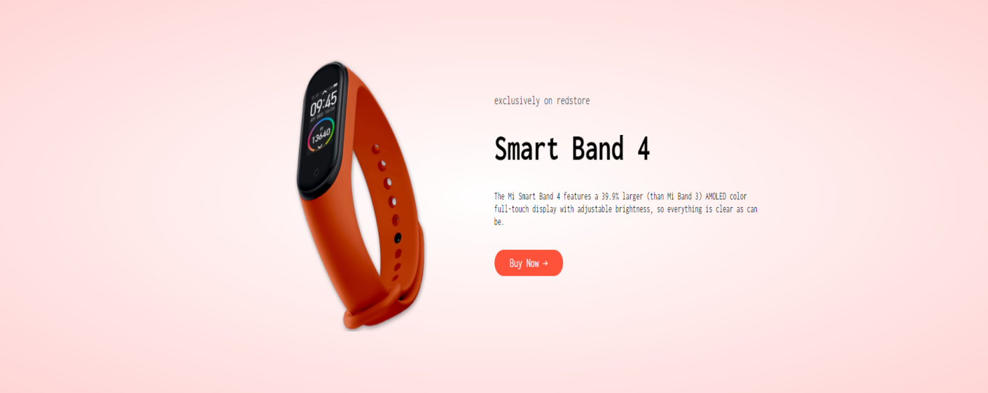

**HTML code:**

<!---offer--->

<div class="offer">

<div class="small-container">

<div class="row">

<div class="col-2">

<img src="images/exclusive.png" class="offer-img">

</div>

<div class="col-2">

<p>exclusively on redstore</p>

<h1>Smart Band 4</h1>

<small>The Mi Smart Band 4 features a 39.9% larger (than Mi Band 3) AMOLED color full-touch display with adjustable brightness, so everything is clear as can be.<br></small>

<a href="" class="btn">Buy Now &#8594;</a>

</div>

</div>

</div>

</div>

**CSS code:**

.offer{

background: radial-gradient(#fff,#ffd6d6);

margin-top: 80px;

padding: 30px 0;

}

.col-2 .offer-img{

padding: 50px;

}

.small{

color: #555;

}

**Logos of brands:**



**HTML code:**

<!--logos-->

<div class="brands">

<div class="small-container">

<div class="row">

<div class="col-5">

<img src="images/logo-coca-cola.png">

</div>

<div class="col-5">

<img src="images/logo-godrej.png">

</div>

<div class="col-5">

<img src="images/logo-oppo.png">

</div>

<div class="col-5">

<img src="images/logo-paypal.png">

</div>

<div class="col-5">

<img src="images/logo-philips.png">

</div>

</div>

</div>

</div>

**Footer section:**



**HTML code:**

<!--footer-->

<div class="footer">

<div class="container">

<div class="row">

<div class="footer-col-1">

<h3>Download</h3>

<p>For android and ios</p>

<div class="app-logo">

<img src="images/play-store.png">

<img src="images/app-store.png">

</div>

</div>

<div class="footer-col-2">

<img src="images/logo-white.png">

<p>For android and ios</p>

</div>

<div class="footer-col-3">

<h3>Useful Links</h3>

<ul>

<li>Coupons</li>

<li>Blog Post</li>

<li>Return Policy</li>

<li>Join Affiliate</li>

</ul>

</div>

<div class="footer-col-4">

<h3>Follow Us</h3>

<ul>

<li>Facebook</li>

<li>Twitter</li>

<li>Instagram</li>

<li>YouTube</li>

</ul>

</div>

</div>

<hr>

<p class="copyright">All claims to the owner</p>

</div>

</div>

**CSS code:**

.footer{

background: #000;

color: #8a8a8a;

font-size: 14px;

padding: 60px 0 20px;

}

.footer p{

color: #8a8a8a;

}

.footer h3{

color: #fff;

margin-bottom: 20px;

}

.footer-col-1, .footer-col-2, .footer-col-3, .footer-col-4{

min-width: 250px;

margin-bottom: 20px;

}

.footer-col-1{

flex-basis: 30%;

}

.footer-col-2{

flex: 1;

text-align: center;

}

.footer-col-2 img{

width: 180px;

margin-bottom: 20px;

}

.footer-col-3, .footer-col-4{

flex-basis: 12%;

text-align: center;

}

ul{

list-style-type: none;

}

.app-logo{

margin-top: 20px;

}

.app-logo img{

width: 140px;

}

.footer hr{

border: none;

background: #b5b5b5;

height: 1px;

margin: 20px 0;

}

.copyright{

text-align: center;

}

.menu-icon{

width: 28px;

margin-left: 20px;

display: none;

}

**Media queries :**

The media queries was applied to each page of the web-site to make the site user friendly when open with devices with different screen size.

**CSS for media queries:**

@media only screen and (max-width: 800px){

nav ul{

position: absolute;

top: 70px;

left: 0;

background: #333;

opacity: 80%;

width: 100%;

overflow: hidden;

transition: max-height 0.5s;

}

nav ul li{

display: block;

margin-right: 50px;

margin-top: 10px;

margin-bottom: 10px;

}

nav ul li a{

color: #fff;

}

.menu-icon{

display: block;

cursor: pointer;

}

}

**The Js code for the home page:**

<script>

var MenuItems = document.getElementById("MenuItems");

MenuItems.style.maxHeight = "0px";

function menutoggle(){

if(MenuItems.style.maxHeight == "0px"){

MenuItems.style.maxHeight = "200px";

}

else

{

MenuItems.style.maxHeight = "0px";

}

}

</script>

**FOR ALL PRODUCTS PAGE**

**The head section of the page was made**

**HTML CODE:**

<!DOCTYPE html>

<html lang="en">

<head>

<meta charset="UTF-8">

<meta name="viewport" content="width=device-width, initial-scale=1.0">

<meta http-equiv="X-UA-Compatible" content="IE=edge">

<meta name="viewport" content="width=device-width, initial-scale=1.0">

<title>All Products</title>

<link rel="stylesheet" href="style.css">

<link rel="preconnect" href="https://fonts.googleapis.com">

<link rel="preconnect" href="https://fonts.gstatic.com" crossorigin>

<link href="https://fonts.googleapis.com/css2?family=Inconsolata:wght@300;400;500;600;700&display=swap" rel="stylesheet">

<link rel="stylesheet" href="https://cdn.jsdelivr.net/npm/@fortawesome/fontawesome-free@6.1.1/css/fontawesome.min.css" integrity="sha384-zIaWifL2YFF1qaDiAo0JFgsmasocJ/rqu7LKYH8CoBEXqGbb9eO+Xi3s6fQhgFWM" crossorigin="anonymous">

</head>

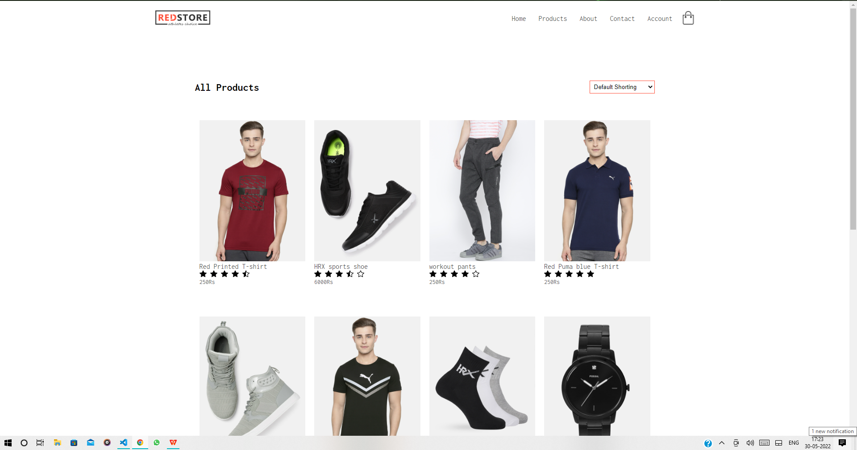

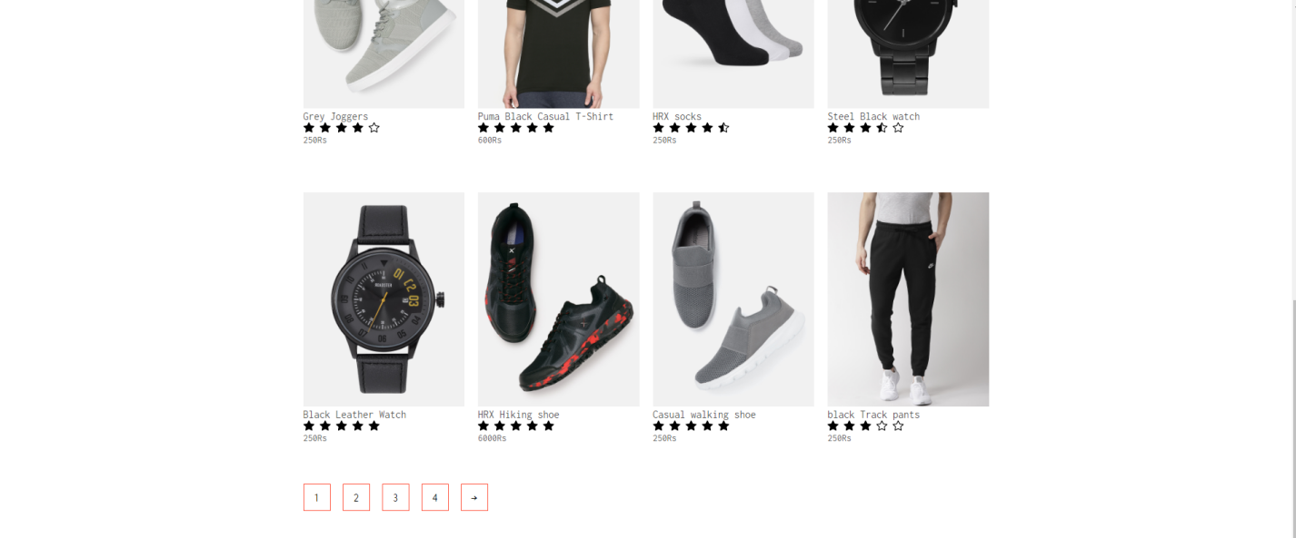

This section consists of the products page with the navigation bar at the top and following that the sorting order with the actual products with their rating and information and links through which these can be bought.

**HTML code:**

<div class="container">

<div class="navbar">

<div class="logo">

<img src="images/logo.png" width="125px" >

</div>

<nav>

<ul id="MenuItems">

<li><a href="home.html">Home</a></li>

<li><a href="products.html">Products</a></li>

<li><a href="">About</a></li>

<li><a href="">Contact</a></li>

<li><a href="account.html">Account</a></li>

</ul>

</nav>

<a href="cart.html"><img src="images/cart.png" width="30px" height="30px"></a>

<img src="images/menu.png" class="menu-icon" onclick="menutoggle()">

</div>

</div>

<div class="small-container">

<div class="row row-2">

<h2>All Products</h2>

<select >

<option>Default Shorting</option>

<option>Short by price</option>

<option>Short by popularity</option>

<option>Short by rating</option>

<option>Short by sales</option>

</select>

</div>

<div class="row">

<div class="col-4">

<a href="product details.html"><img src="images/product-1.jpg"></a>

<a href="product details.html"><h4>Red Printed T-shirt</h4></a>

<div class="rating">

<svg xmlns="http://www.w3.org/2000/svg" width="16" height="16" fill="currentColor" class="bi bi-star-fill" viewBox="0 0 16 16">

<path d="M3.612 15.443c-.386.198-.824-.149-.746-.592l.83-4.73L.173 6.765c-.329-.314-.158-.888.283-.95l4.898-.696L7.538.792c.197-.39.73-.39.927 0l2.184 4.327 4.898.696c.441.062.612.636.282.95l-3.522 3.356.83 4.73c.078.443-.36.79-.746.592L8 13.187l-4.389 2.256z"/>

</svg>

<svg xmlns="http://www.w3.org/2000/svg" width="16" height="16" fill="currentColor" class="bi bi-star-fill" viewBox="0 0 16 16">

<path d="M3.612 15.443c-.386.198-.824-.149-.746-.592l.83-4.73L.173 6.765c-.329-.314-.158-.888.283-.95l4.898-.696L7.538.792c.197-.39.73-.39.927 0l2.184 4.327 4.898.696c.441.062.612.636.282.95l-3.522 3.356.83 4.73c.078.443-.36.79-.746.592L8 13.187l-4.389 2.256z"/>

</svg>

<svg xmlns="http://www.w3.org/2000/svg" width="16" height="16" fill="currentColor" class="bi bi-star-fill" viewBox="0 0 16 16">

<path d="M3.612 15.443c-.386.198-.824-.149-.746-.592l.83-4.73L.173 6.765c-.329-.314-.158-.888.283-.95l4.898-.696L7.538.792c.197-.39.73-.39.927 0l2.184 4.327 4.898.696c.441.062.612.636.282.95l-3.522 3.356.83 4.73c.078.443-.36.79-.746.592L8 13.187l-4.389 2.256z"/>

</svg>

<svg xmlns="http://www.w3.org/2000/svg" width="16" height="16" fill="currentColor" class="bi bi-star-fill" viewBox="0 0 16 16">

<path d="M3.612 15.443c-.386.198-.824-.149-.746-.592l.83-4.73L.173 6.765c-.329-.314-.158-.888.283-.95l4.898-.696L7.538.792c.197-.39.73-.39.927 0l2.184 4.327 4.898.696c.441.062.612.636.282.95l-3.522 3.356.83 4.73c.078.443-.36.79-.746.592L8 13.187l-4.389 2.256z"/>

</svg>

<svg xmlns="http://www.w3.org/2000/svg" width="16" height="16" fill="currentColor" class="bi bi-star-half" viewBox="0 0 16 16">

<path d="M5.354 5.119 7.538.792A.516.516 0 0 1 8 .5c.183 0 .366.097.465.292l2.184 4.327 4.898.696A.537.537 0 0 1 16 6.32a.548.548 0 0 1-.17.445l-3.523 3.356.83 4.73c.078.443-.36.79-.746.592L8 13.187l-4.389 2.256a.52.52 0 0 1-.146.05c-.342.06-.668-.254-.6-.642l.83-4.73L.173 6.765a.55.55 0 0 1-.172-.403.58.58 0 0 1 .085-.302.513.513 0 0 1 .37-.245l4.898-.696zM8 12.027a.5.5 0 0 1 .232.056l3.686 1.894-.694-3.957a.565.565 0 0 1 .162-.505l2.907-2.77-4.052-.576a.525.525 0 0 1-.393-.288L8.001 2.223 8 2.226v9.8z"/>

</svg>

</div>

<p>250Rs</p>

</div>

<div class="col-4">

<img src="images/product-2.jpg">

<h4>HRX sports shoe</h4>

<div class="rating">

<svg xmlns="http://www.w3.org/2000/svg" width="16" height="16" fill="currentColor" class="bi bi-star-fill" viewBox="0 0 16 16">

<path d="M3.612 15.443c-.386.198-.824-.149-.746-.592l.83-4.73L.173 6.765c-.329-.314-.158-.888.283-.95l4.898-.696L7.538.792c.197-.39.73-.39.927 0l2.184 4.327 4.898.696c.441.062.612.636.282.95l-3.522 3.356.83 4.73c.078.443-.36.79-.746.592L8 13.187l-4.389 2.256z"/>

</svg>

<svg xmlns="http://www.w3.org/2000/svg" width="16" height="16" fill="currentColor" class="bi bi-star-fill" viewBox="0 0 16 16">

<path d="M3.612 15.443c-.386.198-.824-.149-.746-.592l.83-4.73L.173 6.765c-.329-.314-.158-.888.283-.95l4.898-.696L7.538.792c.197-.39.73-.39.927 0l2.184 4.327 4.898.696c.441.062.612.636.282.95l-3.522 3.356.83 4.73c.078.443-.36.79-.746.592L8 13.187l-4.389 2.256z"/>

</svg>

<svg xmlns="http://www.w3.org/2000/svg" width="16" height="16" fill="currentColor" class="bi bi-star-fill" viewBox="0 0 16 16">

<path d="M3.612 15.443c-.386.198-.824-.149-.746-.592l.83-4.73L.173 6.765c-.329-.314-.158-.888.283-.95l4.898-.696L7.538.792c.197-.39.73-.39.927 0l2.184 4.327 4.898.696c.441.062.612.636.282.95l-3.522 3.356.83 4.73c.078.443-.36.79-.746.592L8 13.187l-4.389 2.256z"/>

</svg>

<svg xmlns="http://www.w3.org/2000/svg" width="16" height="16" fill="currentColor" class="bi bi-star-half" viewBox="0 0 16 16">

<path d="M5.354 5.119 7.538.792A.516.516 0 0 1 8 .5c.183 0 .366.097.465.292l2.184 4.327 4.898.696A.537.537 0 0 1 16 6.32a.548.548 0 0 1-.17.445l-3.523 3.356.83 4.73c.078.443-.36.79-.746.592L8 13.187l-4.389 2.256a.52.52 0 0 1-.146.05c-.342.06-.668-.254-.6-.642l.83-4.73L.173 6.765a.55.55 0 0 1-.172-.403.58.58 0 0 1 .085-.302.513.513 0 0 1 .37-.245l4.898-.696zM8 12.027a.5.5 0 0 1 .232.056l3.686 1.894-.694-3.957a.565.565 0 0 1 .162-.505l2.907-2.77-4.052-.576a.525.525 0 0 1-.393-.288L8.001 2.223 8 2.226v9.8z"/>

</svg>

<svg xmlns="http://www.w3.org/2000/svg" width="16" height="16" fill="currentColor" class="bi bi-star" viewBox="0 0 16 16">

<path d="M2.866 14.85c-.078.444.36.791.746.593l4.39-2.256 4.389 2.256c.386.198.824-.149.746-.592l-.83-4.73 3.522-3.356c.33-.314.16-.888-.282-.95l-4.898-.696L8.465.792a.513.513 0 0 0-.927 0L5.354 5.12l-4.898.696c-.441.062-.612.636-.283.95l3.523 3.356-.83 4.73zm4.905-2.767-3.686 1.894.694-3.957a.565.565 0 0 0-.163-.505L1.71 6.745l4.052-.576a.525.525 0 0 0 .393-.288L8 2.223l1.847 3.658a.525.525 0 0 0 .393.288l4.052.575-2.906 2.77a.565.565 0 0 0-.163.506l.694 3.957-3.686-1.894a.503.503 0 0 0-.461 0z"/>

</svg>

</div>

<p>6000Rs</p>

</div>

<div class="col-4">

<img src="images/product-3.jpg">

<h4>workout pants</h4>

<div class="rating">

<svg xmlns="http://www.w3.org/2000/svg" width="16" height="16" fill="currentColor" class="bi bi-star-fill" viewBox="0 0 16 16">

<path d="M3.612 15.443c-.386.198-.824-.149-.746-.592l.83-4.73L.173 6.765c-.329-.314-.158-.888.283-.95l4.898-.696L7.538.792c.197-.39.73-.39.927 0l2.184 4.327 4.898.696c.441.062.612.636.282.95l-3.522 3.356.83 4.73c.078.443-.36.79-.746.592L8 13.187l-4.389 2.256z"/>

</svg>

<svg xmlns="http://www.w3.org/2000/svg" width="16" height="16" fill="currentColor" class="bi bi-star-fill" viewBox="0 0 16 16">

<path d="M3.612 15.443c-.386.198-.824-.149-.746-.592l.83-4.73L.173 6.765c-.329-.314-.158-.888.283-.95l4.898-.696L7.538.792c.197-.39.73-.39.927 0l2.184 4.327 4.898.696c.441.062.612.636.282.95l-3.522 3.356.83 4.73c.078.443-.36.79-.746.592L8 13.187l-4.389 2.256z"/>

</svg>

<svg xmlns="http://www.w3.org/2000/svg" width="16" height="16" fill="currentColor" class="bi bi-star-fill" viewBox="0 0 16 16">

<path d="M3.612 15.443c-.386.198-.824-.149-.746-.592l.83-4.73L.173 6.765c-.329-.314-.158-.888.283-.95l4.898-.696L7.538.792c.197-.39.73-.39.927 0l2.184 4.327 4.898.696c.441.062.612.636.282.95l-3.522 3.356.83 4.73c.078.443-.36.79-.746.592L8 13.187l-4.389 2.256z"/>

</svg>

<svg xmlns="http://www.w3.org/2000/svg" width="16" height="16" fill="currentColor" class="bi bi-star-fill" viewBox="0 0 16 16">

<path d="M3.612 15.443c-.386.198-.824-.149-.746-.592l.83-4.73L.173 6.765c-.329-.314-.158-.888.283-.95l4.898-.696L7.538.792c.197-.39.73-.39.927 0l2.184 4.327 4.898.696c.441.062.612.636.282.95l-3.522 3.356.83 4.73c.078.443-.36.79-.746.592L8 13.187l-4.389 2.256z"/>

</svg>

<svg xmlns="http://www.w3.org/2000/svg" width="16" height="16" fill="currentColor" class="bi bi-star" viewBox="0 0 16 16">

<path d="M2.866 14.85c-.078.444.36.791.746.593l4.39-2.256 4.389 2.256c.386.198.824-.149.746-.592l-.83-4.73 3.522-3.356c.33-.314.16-.888-.282-.95l-4.898-.696L8.465.792a.513.513 0 0 0-.927 0L5.354 5.12l-4.898.696c-.441.062-.612.636-.283.95l3.523 3.356-.83 4.73zm4.905-2.767-3.686 1.894.694-3.957a.565.565 0 0 0-.163-.505L1.71 6.745l4.052-.576a.525.525 0 0 0 .393-.288L8 2.223l1.847 3.658a.525.525 0 0 0 .393.288l4.052.575-2.906 2.77a.565.565 0 0 0-.163.506l.694 3.957-3.686-1.894a.503.503 0 0 0-.461 0z"/>

</svg>

</div>

<p>250Rs</p>

</div>

<div class="col-4">

<img src="images/product-4.jpg">

<h4>Red Puma blue T-shirt</h4>

<div class="rating">

<svg xmlns="http://www.w3.org/2000/svg" width="16" height="16" fill="currentColor" class="bi bi-star-fill" viewBox="0 0 16 16">

<path d="M3.612 15.443c-.386.198-.824-.149-.746-.592l.83-4.73L.173 6.765c-.329-.314-.158-.888.283-.95l4.898-.696L7.538.792c.197-.39.73-.39.927 0l2.184 4.327 4.898.696c.441.062.612.636.282.95l-3.522 3.356.83 4.73c.078.443-.36.79-.746.592L8 13.187l-4.389 2.256z"/>

</svg>

<svg xmlns="http://www.w3.org/2000/svg" width="16" height="16" fill="currentColor" class="bi bi-star-fill" viewBox="0 0 16 16">

<path d="M3.612 15.443c-.386.198-.824-.149-.746-.592l.83-4.73L.173 6.765c-.329-.314-.158-.888.283-.95l4.898-.696L7.538.792c.197-.39.73-.39.927 0l2.184 4.327 4.898.696c.441.062.612.636.282.95l-3.522 3.356.83 4.73c.078.443-.36.79-.746.592L8 13.187l-4.389 2.256z"/>

</svg>

<svg xmlns="http://www.w3.org/2000/svg" width="16" height="16" fill="currentColor" class="bi bi-star-fill" viewBox="0 0 16 16">

<path d="M3.612 15.443c-.386.198-.824-.149-.746-.592l.83-4.73L.173 6.765c-.329-.314-.158-.888.283-.95l4.898-.696L7.538.792c.197-.39.73-.39.927 0l2.184 4.327 4.898.696c.441.062.612.636.282.95l-3.522 3.356.83 4.73c.078.443-.36.79-.746.592L8 13.187l-4.389 2.256z"/>

</svg>

<svg xmlns="http://www.w3.org/2000/svg" width="16" height="16" fill="currentColor" class="bi bi-star-fill" viewBox="0 0 16 16">

<path d="M3.612 15.443c-.386.198-.824-.149-.746-.592l.83-4.73L.173 6.765c-.329-.314-.158-.888.283-.95l4.898-.696L7.538.792c.197-.39.73-.39.927 0l2.184 4.327 4.898.696c.441.062.612.636.282.95l-3.522 3.356.83 4.73c.078.443-.36.79-.746.592L8 13.187l-4.389 2.256z"/>

</svg>

<svg xmlns="http://www.w3.org/2000/svg" width="16" height="16" fill="currentColor" class="bi bi-star-fill" viewBox="0 0 16 16">

<path d="M3.612 15.443c-.386.198-.824-.149-.746-.592l.83-4.73L.173 6.765c-.329-.314-.158-.888.283-.95l4.898-.696L7.538.792c.197-.39.73-.39.927 0l2.184 4.327 4.898.696c.441.062.612.636.282.95l-3.522 3.356.83 4.73c.078.443-.36.79-.746.592L8 13.187l-4.389 2.256z"/>

</svg>

</div>

<p>250Rs</p>

</div>

</div>

<div class="row">

<div class="col-4">

<img src="images/product-5.jpg">

<h4>Grey Joggers</h4>

<div class="rating">

<svg xmlns="http://www.w3.org/2000/svg" width="16" height="16" fill="currentColor" class="bi bi-star-fill" viewBox="0 0 16 16">

<path d="M3.612 15.443c-.386.198-.824-.149-.746-.592l.83-4.73L.173 6.765c-.329-.314-.158-.888.283-.95l4.898-.696L7.538.792c.197-.39.73-.39.927 0l2.184 4.327 4.898.696c.441.062.612.636.282.95l-3.522 3.356.83 4.73c.078.443-.36.79-.746.592L8 13.187l-4.389 2.256z"/>

</svg>

<svg xmlns="http://www.w3.org/2000/svg" width="16" height="16" fill="currentColor" class="bi bi-star-fill" viewBox="0 0 16 16">

<path d="M3.612 15.443c-.386.198-.824-.149-.746-.592l.83-4.73L.173 6.765c-.329-.314-.158-.888.283-.95l4.898-.696L7.538.792c.197-.39.73-.39.927 0l2.184 4.327 4.898.696c.441.062.612.636.282.95l-3.522 3.356.83 4.73c.078.443-.36.79-.746.592L8 13.187l-4.389 2.256z"/>

</svg>

<svg xmlns="http://www.w3.org/2000/svg" width="16" height="16" fill="currentColor" class="bi bi-star-fill" viewBox="0 0 16 16">

<path d="M3.612 15.443c-.386.198-.824-.149-.746-.592l.83-4.73L.173 6.765c-.329-.314-.158-.888.283-.95l4.898-.696L7.538.792c.197-.39.73-.39.927 0l2.184 4.327 4.898.696c.441.062.612.636.282.95l-3.522 3.356.83 4.73c.078.443-.36.79-.746.592L8 13.187l-4.389 2.256z"/>

</svg>

<svg xmlns="http://www.w3.org/2000/svg" width="16" height="16" fill="currentColor" class="bi bi-star-fill" viewBox="0 0 16 16">

<path d="M3.612 15.443c-.386.198-.824-.149-.746-.592l.83-4.73L.173 6.765c-.329-.314-.158-.888.283-.95l4.898-.696L7.538.792c.197-.39.73-.39.927 0l2.184 4.327 4.898.696c.441.062.612.636.282.95l-3.522 3.356.83 4.73c.078.443-.36.79-.746.592L8 13.187l-4.389 2.256z"/>

</svg>

<svg xmlns="http://www.w3.org/2000/svg" width="16" height="16" fill="currentColor" class="bi bi-star" viewBox="0 0 16 16">

<path d="M2.866 14.85c-.078.444.36.791.746.593l4.39-2.256 4.389 2.256c.386.198.824-.149.746-.592l-.83-4.73 3.522-3.356c.33-.314.16-.888-.282-.95l-4.898-.696L8.465.792a.513.513 0 0 0-.927 0L5.354 5.12l-4.898.696c-.441.062-.612.636-.283.95l3.523 3.356-.83 4.73zm4.905-2.767-3.686 1.894.694-3.957a.565.565 0 0 0-.163-.505L1.71 6.745l4.052-.576a.525.525 0 0 0 .393-.288L8 2.223l1.847 3.658a.525.525 0 0 0 .393.288l4.052.575-2.906 2.77a.565.565 0 0 0-.163.506l.694 3.957-3.686-1.894a.503.503 0 0 0-.461 0z"/>

</svg>

</div>

<p>250Rs</p>

</div>

<div class="col-4">

<img src="images/product-6.jpg">

<h4>Puma Black Casual T-Shirt</h4>

<div class="rating">

<svg xmlns="http://www.w3.org/2000/svg" width="16" height="16" fill="currentColor" class="bi bi-star-fill" viewBox="0 0 16 16">

<path d="M3.612 15.443c-.386.198-.824-.149-.746-.592l.83-4.73L.173 6.765c-.329-.314-.158-.888.283-.95l4.898-.696L7.538.792c.197-.39.73-.39.927 0l2.184 4.327 4.898.696c.441.062.612.636.282.95l-3.522 3.356.83 4.73c.078.443-.36.79-.746.592L8 13.187l-4.389 2.256z"/>

</svg>

<svg xmlns="http://www.w3.org/2000/svg" width="16" height="16" fill="currentColor" class="bi bi-star-fill" viewBox="0 0 16 16">

<path d="M3.612 15.443c-.386.198-.824-.149-.746-.592l.83-4.73L.173 6.765c-.329-.314-.158-.888.283-.95l4.898-.696L7.538.792c.197-.39.73-.39.927 0l2.184 4.327 4.898.696c.441.062.612.636.282.95l-3.522 3.356.83 4.73c.078.443-.36.79-.746.592L8 13.187l-4.389 2.256z"/>

</svg>

<svg xmlns="http://www.w3.org/2000/svg" width="16" height="16" fill="currentColor" class="bi bi-star-fill" viewBox="0 0 16 16">

<path d="M3.612 15.443c-.386.198-.824-.149-.746-.592l.83-4.73L.173 6.765c-.329-.314-.158-.888.283-.95l4.898-.696L7.538.792c.197-.39.73-.39.927 0l2.184 4.327 4.898.696c.441.062.612.636.282.95l-3.522 3.356.83 4.73c.078.443-.36.79-.746.592L8 13.187l-4.389 2.256z"/>

</svg>

<svg xmlns="http://www.w3.org/2000/svg" width="16" height="16" fill="currentColor" class="bi bi-star-fill" viewBox="0 0 16 16">

<path d="M3.612 15.443c-.386.198-.824-.149-.746-.592l.83-4.73L.173 6.765c-.329-.314-.158-.888.283-.95l4.898-.696L7.538.792c.197-.39.73-.39.927 0l2.184 4.327 4.898.696c.441.062.612.636.282.95l-3.522 3.356.83 4.73c.078.443-.36.79-.746.592L8 13.187l-4.389 2.256z"/>

</svg>

<svg xmlns="http://www.w3.org/2000/svg" width="16" height="16" fill="currentColor" class="bi bi-star-fill" viewBox="0 0 16 16">

<path d="M3.612 15.443c-.386.198-.824-.149-.746-.592l.83-4.73L.173 6.765c-.329-.314-.158-.888.283-.95l4.898-.696L7.538.792c.197-.39.73-.39.927 0l2.184 4.327 4.898.696c.441.062.612.636.282.95l-3.522 3.356.83 4.73c.078.443-.36.79-.746.592L8 13.187l-4.389 2.256z"/>

</svg>

</div>

<p>600Rs</p>

</div>

<div class="col-4">

<img src="images/product-7.jpg">

<h4>HRX socks</h4>

<div class="rating">

<svg xmlns="http://www.w3.org/2000/svg" width="16" height="16" fill="currentColor" class="bi bi-star-fill" viewBox="0 0 16 16">

<path d="M3.612 15.443c-.386.198-.824-.149-.746-.592l.83-4.73L.173 6.765c-.329-.314-.158-.888.283-.95l4.898-.696L7.538.792c.197-.39.73-.39.927 0l2.184 4.327 4.898.696c.441.062.612.636.282.95l-3.522 3.356.83 4.73c.078.443-.36.79-.746.592L8 13.187l-4.389 2.256z"/>

</svg>

<svg xmlns="http://www.w3.org/2000/svg" width="16" height="16" fill="currentColor" class="bi bi-star-fill" viewBox="0 0 16 16">

<path d="M3.612 15.443c-.386.198-.824-.149-.746-.592l.83-4.73L.173 6.765c-.329-.314-.158-.888.283-.95l4.898-.696L7.538.792c.197-.39.73-.39.927 0l2.184 4.327 4.898.696c.441.062.612.636.282.95l-3.522 3.356.83 4.73c.078.443-.36.79-.746.592L8 13.187l-4.389 2.256z"/>

</svg>

<svg xmlns="http://www.w3.org/2000/svg" width="16" height="16" fill="currentColor" class="bi bi-star-fill" viewBox="0 0 16 16">

<path d="M3.612 15.443c-.386.198-.824-.149-.746-.592l.83-4.73L.173 6.765c-.329-.314-.158-.888.283-.95l4.898-.696L7.538.792c.197-.39.73-.39.927 0l2.184 4.327 4.898.696c.441.062.612.636.282.95l-3.522 3.356.83 4.73c.078.443-.36.79-.746.592L8 13.187l-4.389 2.256z"/>

</svg>

<svg xmlns="http://www.w3.org/2000/svg" width="16" height="16" fill="currentColor" class="bi bi-star-fill" viewBox="0 0 16 16">

<path d="M3.612 15.443c-.386.198-.824-.149-.746-.592l.83-4.73L.173 6.765c-.329-.314-.158-.888.283-.95l4.898-.696L7.538.792c.197-.39.73-.39.927 0l2.184 4.327 4.898.696c.441.062.612.636.282.95l-3.522 3.356.83 4.73c.078.443-.36.79-.746.592L8 13.187l-4.389 2.256z"/>

</svg>

<svg xmlns="http://www.w3.org/2000/svg" width="16" height="16" fill="currentColor" class="bi bi-star-half" viewBox="0 0 16 16">

<path d="M5.354 5.119 7.538.792A.516.516 0 0 1 8 .5c.183 0 .366.097.465.292l2.184 4.327 4.898.696A.537.537 0 0 1 16 6.32a.548.548 0 0 1-.17.445l-3.523 3.356.83 4.73c.078.443-.36.79-.746.592L8 13.187l-4.389 2.256a.52.52 0 0 1-.146.05c-.342.06-.668-.254-.6-.642l.83-4.73L.173 6.765a.55.55 0 0 1-.172-.403.58.58 0 0 1 .085-.302.513.513 0 0 1 .37-.245l4.898-.696zM8 12.027a.5.5 0 0 1 .232.056l3.686 1.894-.694-3.957a.565.565 0 0 1 .162-.505l2.907-2.77-4.052-.576a.525.525 0 0 1-.393-.288L8.001 2.223 8 2.226v9.8z"/>

</svg>

</div>

<p>250Rs</p>

</div>

<div class="col-4">

<img src="images/product-8.jpg">

<h4>Steel Black watch</h4>

<div class="rating">

<svg xmlns="http://www.w3.org/2000/svg" width="16" height="16" fill="currentColor" class="bi bi-star-fill" viewBox="0 0 16 16">

<path d="M3.612 15.443c-.386.198-.824-.149-.746-.592l.83-4.73L.173 6.765c-.329-.314-.158-.888.283-.95l4.898-.696L7.538.792c.197-.39.73-.39.927 0l2.184 4.327 4.898.696c.441.062.612.636.282.95l-3.522 3.356.83 4.73c.078.443-.36.79-.746.592L8 13.187l-4.389 2.256z"/>

</svg>

<svg xmlns="http://www.w3.org/2000/svg" width="16" height="16" fill="currentColor" class="bi bi-star-fill" viewBox="0 0 16 16">

<path d="M3.612 15.443c-.386.198-.824-.149-.746-.592l.83-4.73L.173 6.765c-.329-.314-.158-.888.283-.95l4.898-.696L7.538.792c.197-.39.73-.39.927 0l2.184 4.327 4.898.696c.441.062.612.636.282.95l-3.522 3.356.83 4.73c.078.443-.36.79-.746.592L8 13.187l-4.389 2.256z"/>

</svg>

<svg xmlns="http://www.w3.org/2000/svg" width="16" height="16" fill="currentColor" class="bi bi-star-fill" viewBox="0 0 16 16">

<path d="M3.612 15.443c-.386.198-.824-.149-.746-.592l.83-4.73L.173 6.765c-.329-.314-.158-.888.283-.95l4.898-.696L7.538.792c.197-.39.73-.39.927 0l2.184 4.327 4.898.696c.441.062.612.636.282.95l-3.522 3.356.83 4.73c.078.443-.36.79-.746.592L8 13.187l-4.389 2.256z"/>

</svg>

<svg xmlns="http://www.w3.org/2000/svg" width="16" height="16" fill="currentColor" class="bi bi-star-half" viewBox="0 0 16 16">

<path d="M5.354 5.119 7.538.792A.516.516 0 0 1 8 .5c.183 0 .366.097.465.292l2.184 4.327 4.898.696A.537.537 0 0 1 16 6.32a.548.548 0 0 1-.17.445l-3.523 3.356.83 4.73c.078.443-.36.79-.746.592L8 13.187l-4.389 2.256a.52.52 0 0 1-.146.05c-.342.06-.668-.254-.6-.642l.83-4.73L.173 6.765a.55.55 0 0 1-.172-.403.58.58 0 0 1 .085-.302.513.513 0 0 1 .37-.245l4.898-.696zM8 12.027a.5.5 0 0 1 .232.056l3.686 1.894-.694-3.957a.565.565 0 0 1 .162-.505l2.907-2.77-4.052-.576a.525.525 0 0 1-.393-.288L8.001 2.223 8 2.226v9.8z"/>

</svg>

<svg xmlns="http://www.w3.org/2000/svg" width="16" height="16" fill="currentColor" class="bi bi-star" viewBox="0 0 16 16">

<path d="M2.866 14.85c-.078.444.36.791.746.593l4.39-2.256 4.389 2.256c.386.198.824-.149.746-.592l-.83-4.73 3.522-3.356c.33-.314.16-.888-.282-.95l-4.898-.696L8.465.792a.513.513 0 0 0-.927 0L5.354 5.12l-4.898.696c-.441.062-.612.636-.283.95l3.523 3.356-.83 4.73zm4.905-2.767-3.686 1.894.694-3.957a.565.565 0 0 0-.163-.505L1.71 6.745l4.052-.576a.525.525 0 0 0 .393-.288L8 2.223l1.847 3.658a.525.525 0 0 0 .393.288l4.052.575-2.906 2.77a.565.565 0 0 0-.163.506l.694 3.957-3.686-1.894a.503.503 0 0 0-.461 0z"/>

</svg>

</div>

<p>250Rs</p>

</div>

</div>

<div class="row">

<div class="col-4">

<img src="images/product-9.jpg">

<h4>Black Leather Watch</h4>

<div class="rating">

<svg xmlns="http://www.w3.org/2000/svg" width="16" height="16" fill="currentColor" class="bi bi-star-fill" viewBox="0 0 16 16">

<path d="M3.612 15.443c-.386.198-.824-.149-.746-.592l.83-4.73L.173 6.765c-.329-.314-.158-.888.283-.95l4.898-.696L7.538.792c.197-.39.73-.39.927 0l2.184 4.327 4.898.696c.441.062.612.636.282.95l-3.522 3.356.83 4.73c.078.443-.36.79-.746.592L8 13.187l-4.389 2.256z"/>

</svg>

<svg xmlns="http://www.w3.org/2000/svg" width="16" height="16" fill="currentColor" class="bi bi-star-fill" viewBox="0 0 16 16">

<path d="M3.612 15.443c-.386.198-.824-.149-.746-.592l.83-4.73L.173 6.765c-.329-.314-.158-.888.283-.95l4.898-.696L7.538.792c.197-.39.73-.39.927 0l2.184 4.327 4.898.696c.441.062.612.636.282.95l-3.522 3.356.83 4.73c.078.443-.36.79-.746.592L8 13.187l-4.389 2.256z"/>

</svg>

<svg xmlns="http://www.w3.org/2000/svg" width="16" height="16" fill="currentColor" class="bi bi-star-fill" viewBox="0 0 16 16">

<path d="M3.612 15.443c-.386.198-.824-.149-.746-.592l.83-4.73L.173 6.765c-.329-.314-.158-.888.283-.95l4.898-.696L7.538.792c.197-.39.73-.39.927 0l2.184 4.327 4.898.696c.441.062.612.636.282.95l-3.522 3.356.83 4.73c.078.443-.36.79-.746.592L8 13.187l-4.389 2.256z"/>

</svg>

<svg xmlns="http://www.w3.org/2000/svg" width="16" height="16" fill="currentColor" class="bi bi-star-fill" viewBox="0 0 16 16">

<path d="M3.612 15.443c-.386.198-.824-.149-.746-.592l.83-4.73L.173 6.765c-.329-.314-.158-.888.283-.95l4.898-.696L7.538.792c.197-.39.73-.39.927 0l2.184 4.327 4.898.696c.441.062.612.636.282.95l-3.522 3.356.83 4.73c.078.443-.36.79-.746.592L8 13.187l-4.389 2.256z"/>

</svg>

<svg xmlns="http://www.w3.org/2000/svg" width="16" height="16" fill="currentColor" class="bi bi-star-fill" viewBox="0 0 16 16">

<path d="M3.612 15.443c-.386.198-.824-.149-.746-.592l.83-4.73L.173 6.765c-.329-.314-.158-.888.283-.95l4.898-.696L7.538.792c.197-.39.73-.39.927 0l2.184 4.327 4.898.696c.441.062.612.636.282.95l-3.522 3.356.83 4.73c.078.443-.36.79-.746.592L8 13.187l-4.389 2.256z"/>

</svg>

</div>

<p>250Rs</p>

</div>

<div class="col-4">

<img src="images/product-10.jpg">

<h4>HRX Hiking shoe</h4>

<div class="rating">

<svg xmlns="http://www.w3.org/2000/svg" width="16" height="16" fill="currentColor" class="bi bi-star-fill" viewBox="0 0 16 16">

<path d="M3.612 15.443c-.386.198-.824-.149-.746-.592l.83-4.73L.173 6.765c-.329-.314-.158-.888.283-.95l4.898-.696L7.538.792c.197-.39.73-.39.927 0l2.184 4.327 4.898.696c.441.062.612.636.282.95l-3.522 3.356.83 4.73c.078.443-.36.79-.746.592L8 13.187l-4.389 2.256z"/>

</svg>

<svg xmlns="http://www.w3.org/2000/svg" width="16" height="16" fill="currentColor" class="bi bi-star-fill" viewBox="0 0 16 16">

<path d="M3.612 15.443c-.386.198-.824-.149-.746-.592l.83-4.73L.173 6.765c-.329-.314-.158-.888.283-.95l4.898-.696L7.538.792c.197-.39.73-.39.927 0l2.184 4.327 4.898.696c.441.062.612.636.282.95l-3.522 3.356.83 4.73c.078.443-.36.79-.746.592L8 13.187l-4.389 2.256z"/>

</svg>

<svg xmlns="http://www.w3.org/2000/svg" width="16" height="16" fill="currentColor" class="bi bi-star-fill" viewBox="0 0 16 16">

<path d="M3.612 15.443c-.386.198-.824-.149-.746-.592l.83-4.73L.173 6.765c-.329-.314-.158-.888.283-.95l4.898-.696L7.538.792c.197-.39.73-.39.927 0l2.184 4.327 4.898.696c.441.062.612.636.282.95l-3.522 3.356.83 4.73c.078.443-.36.79-.746.592L8 13.187l-4.389 2.256z"/>

</svg>

<svg xmlns="http://www.w3.org/2000/svg" width="16" height="16" fill="currentColor" class="bi bi-star-fill" viewBox="0 0 16 16">

<path d="M3.612 15.443c-.386.198-.824-.149-.746-.592l.83-4.73L.173 6.765c-.329-.314-.158-.888.283-.95l4.898-.696L7.538.792c.197-.39.73-.39.927 0l2.184 4.327 4.898.696c.441.062.612.636.282.95l-3.522 3.356.83 4.73c.078.443-.36.79-.746.592L8 13.187l-4.389 2.256z"/>

</svg>

<svg xmlns="http://www.w3.org/2000/svg" width="16" height="16" fill="currentColor" class="bi bi-star-fill" viewBox="0 0 16 16">

<path d="M3.612 15.443c-.386.198-.824-.149-.746-.592l.83-4.73L.173 6.765c-.329-.314-.158-.888.283-.95l4.898-.696L7.538.792c.197-.39.73-.39.927 0l2.184 4.327 4.898.696c.441.062.612.636.282.95l-3.522 3.356.83 4.73c.078.443-.36.79-.746.592L8 13.187l-4.389 2.256z"/>

</svg>

</div>

<p>6000Rs</p>

</div>

<div class="col-4">

<img src="images/product-11.jpg">

<h4>Casual walking shoe</h4>

<div class="rating">

<svg xmlns="http://www.w3.org/2000/svg" width="16" height="16" fill="currentColor" class="bi bi-star-fill" viewBox="0 0 16 16">

<path d="M3.612 15.443c-.386.198-.824-.149-.746-.592l.83-4.73L.173 6.765c-.329-.314-.158-.888.283-.95l4.898-.696L7.538.792c.197-.39.73-.39.927 0l2.184 4.327 4.898.696c.441.062.612.636.282.95l-3.522 3.356.83 4.73c.078.443-.36.79-.746.592L8 13.187l-4.389 2.256z"/>

</svg>

<svg xmlns="http://www.w3.org/2000/svg" width="16" height="16" fill="currentColor" class="bi bi-star-fill" viewBox="0 0 16 16">

<path d="M3.612 15.443c-.386.198-.824-.149-.746-.592l.83-4.73L.173 6.765c-.329-.314-.158-.888.283-.95l4.898-.696L7.538.792c.197-.39.73-.39.927 0l2.184 4.327 4.898.696c.441.062.612.636.282.95l-3.522 3.356.83 4.73c.078.443-.36.79-.746.592L8 13.187l-4.389 2.256z"/>

</svg>

<svg xmlns="http://www.w3.org/2000/svg" width="16" height="16" fill="currentColor" class="bi bi-star-fill" viewBox="0 0 16 16">

<path d="M3.612 15.443c-.386.198-.824-.149-.746-.592l.83-4.73L.173 6.765c-.329-.314-.158-.888.283-.95l4.898-.696L7.538.792c.197-.39.73-.39.927 0l2.184 4.327 4.898.696c.441.062.612.636.282.95l-3.522 3.356.83 4.73c.078.443-.36.79-.746.592L8 13.187l-4.389 2.256z"/>

</svg>

<svg xmlns="http://www.w3.org/2000/svg" width="16" height="16" fill="currentColor" class="bi bi-star-fill" viewBox="0 0 16 16">

<path d="M3.612 15.443c-.386.198-.824-.149-.746-.592l.83-4.73L.173 6.765c-.329-.314-.158-.888.283-.95l4.898-.696L7.538.792c.197-.39.73-.39.927 0l2.184 4.327 4.898.696c.441.062.612.636.282.95l-3.522 3.356.83 4.73c.078.443-.36.79-.746.592L8 13.187l-4.389 2.256z"/>

</svg>

<svg xmlns="http://www.w3.org/2000/svg" width="16" height="16" fill="currentColor" class="bi bi-star-fill" viewBox="0 0 16 16">

<path d="M3.612 15.443c-.386.198-.824-.149-.746-.592l.83-4.73L.173 6.765c-.329-.314-.158-.888.283-.95l4.898-.696L7.538.792c.197-.39.73-.39.927 0l2.184 4.327 4.898.696c.441.062.612.636.282.95l-3.522 3.356.83 4.73c.078.443-.36.79-.746.592L8 13.187l-4.389 2.256z"/>

</svg>

</div>

<p>250Rs</p>

</div>

<div class="col-4">

<img src="images/product-12.jpg">

<h4>black Track pants</h4>

<div class="rating">

<svg xmlns="http://www.w3.org/2000/svg" width="16" height="16" fill="currentColor" class="bi bi-star-fill" viewBox="0 0 16 16">

<path d="M3.612 15.443c-.386.198-.824-.149-.746-.592l.83-4.73L.173 6.765c-.329-.314-.158-.888.283-.95l4.898-.696L7.538.792c.197-.39.73-.39.927 0l2.184 4.327 4.898.696c.441.062.612.636.282.95l-3.522 3.356.83 4.73c.078.443-.36.79-.746.592L8 13.187l-4.389 2.256z"/>

</svg>

<svg xmlns="http://www.w3.org/2000/svg" width="16" height="16" fill="currentColor" class="bi bi-star-fill" viewBox="0 0 16 16">

<path d="M3.612 15.443c-.386.198-.824-.149-.746-.592l.83-4.73L.173 6.765c-.329-.314-.158-.888.283-.95l4.898-.696L7.538.792c.197-.39.73-.39.927 0l2.184 4.327 4.898.696c.441.062.612.636.282.95l-3.522 3.356.83 4.73c.078.443-.36.79-.746.592L8 13.187l-4.389 2.256z"/>

</svg>

<svg xmlns="http://www.w3.org/2000/svg" width="16" height="16" fill="currentColor" class="bi bi-star-fill" viewBox="0 0 16 16">

<path d="M3.612 15.443c-.386.198-.824-.149-.746-.592l.83-4.73L.173 6.765c-.329-.314-.158-.888.283-.95l4.898-.696L7.538.792c.197-.39.73-.39.927 0l2.184 4.327 4.898.696c.441.062.612.636.282.95l-3.522 3.356.83 4.73c.078.443-.36.79-.746.592L8 13.187l-4.389 2.256z"/>

</svg>

<svg xmlns="http://www.w3.org/2000/svg" width="16" height="16" fill="currentColor" class="bi bi-star" viewBox="0 0 16 16">

<path d="M2.866 14.85c-.078.444.36.791.746.593l4.39-2.256 4.389 2.256c.386.198.824-.149.746-.592l-.83-4.73 3.522-3.356c.33-.314.16-.888-.282-.95l-4.898-.696L8.465.792a.513.513 0 0 0-.927 0L5.354 5.12l-4.898.696c-.441.062-.612.636-.283.95l3.523 3.356-.83 4.73zm4.905-2.767-3.686 1.894.694-3.957a.565.565 0 0 0-.163-.505L1.71 6.745l4.052-.576a.525.525 0 0 0 .393-.288L8 2.223l1.847 3.658a.525.525 0 0 0 .393.288l4.052.575-2.906 2.77a.565.565 0 0 0-.163.506l.694 3.957-3.686-1.894a.503.503 0 0 0-.461 0z"/>

</svg>

<svg xmlns="http://www.w3.org/2000/svg" width="16" height="16" fill="currentColor" class="bi bi-star" viewBox="0 0 16 16">

<path d="M2.866 14.85c-.078.444.36.791.746.593l4.39-2.256 4.389 2.256c.386.198.824-.149.746-.592l-.83-4.73 3.522-3.356c.33-.314.16-.888-.282-.95l-4.898-.696L8.465.792a.513.513 0 0 0-.927 0L5.354 5.12l-4.898.696c-.441.062-.612.636-.283.95l3.523 3.356-.83 4.73zm4.905-2.767-3.686 1.894.694-3.957a.565.565 0 0 0-.163-.505L1.71 6.745l4.052-.576a.525.525 0 0 0 .393-.288L8 2.223l1.847 3.658a.525.525 0 0 0 .393.288l4.052.575-2.906 2.77a.565.565 0 0 0-.163.506l.694 3.957-3.686-1.894a.503.503 0 0 0-.461 0z"/>

</svg>

</div>

<p>250Rs</p>

</div>

</div>

<div class="page-btn">

<span>1</span>

<span>2</span>

<span>3</span>

<span>4</span>

<span>&#8594;</span>

</div>

</div>

**Footer section:**



**HTML code:**

<!--footer-->

<div class="footer">

<div class="container">

<div class="row">

<div class="footer-col-1">

<h3>Download</h3>

<p>For android and ios</p>

<div class="app-logo">

<img src="images/play-store.png">

<img src="images/app-store.png">

</div>

</div>

<div class="footer-col-2">

<img src="images/logo-white.png">

<p>For android and ios</p>

</div>

<div class="footer-col-3">

<h3>Useful Links</h3>

<ul>

<li>Coupons</li>

<li>Blog Post</li>

<li>Return Policy</li>

<li>Join Affiliate</li>

</ul>

</div>

<div class="footer-col-4">

<h3>Follow Us</h3>

<ul>

<li>Facebook</li>

<li>Twitter</li>

<li>Instagram</li>

<li>YouTube</li>

</ul>

</div>

</div>

<hr>

<p class="copyright">All claims to the owner</p>

</div>

</div>

**CSS code:**

.footer{

background: #000;

color: #8a8a8a;

font-size: 14px;

padding: 60px 0 20px;

}

.footer p{

color: #8a8a8a;

}

.footer h3{

color: #fff;

margin-bottom: 20px;

}

.footer-col-1, .footer-col-2, .footer-col-3, .footer-col-4{

min-width: 250px;

margin-bottom: 20px;

}

.footer-col-1{

flex-basis: 30%;

}

.footer-col-2{

flex: 1;

text-align: center;

}

.footer-col-2 img{

width: 180px;

margin-bottom: 20px;

}

.footer-col-3, .footer-col-4{

flex-basis: 12%;

text-align: center;

}

ul{

list-style-type: none;

}

.app-logo{

margin-top: 20px;

}

.app-logo img{

width: 140px;

}

.footer hr{

border: none;

background: #b5b5b5;

height: 1px;

margin: 20px 0;

}

.copyright{

text-align: center;

}

.menu-icon{

width: 28px;

margin-left: 20px;

display: none;

}

**The JavaScript part:**

<script>

var MenuItems = document.getElementById("MenuItems");

MenuItems.style.maxHeight = "0px";

function menutoggle(){

if(MenuItems.style.maxHeight == "0px"){

MenuItems.style.maxHeight = "200px";

}

else

{

MenuItems.style.maxHeight = "0px";

}

}

</script>

</body>

**PRODUCT DETAILS PAGE**

This page consists of a product when clicked on and gives the full description in details

**Head:**

<!DOCTYPE html>

<html lang="en">

<head>

<meta charset="UTF-8">

<meta name="viewport" content="width=device-width, initial-scale=1.0">

<meta http-equiv="X-UA-Compatible" content="IE=edge">

<meta name="viewport" content="width=device-width, initial-scale=1.0">

<title>All Products</title>

<link rel="stylesheet" href="style.css">

<link rel="preconnect" href="https://fonts.googleapis.com">

<link rel="preconnect" href="https://fonts.gstatic.com" crossorigin>

<link href="https://fonts.googleapis.com/css2?family=Inconsolata:wght@300;400;500;600;700&display=swap" rel="stylesheet">

<link rel="stylesheet" href="https://cdn.jsdelivr.net/npm/@fortawesome/fontawesome-free@6.1.1/css/fontawesome.min.css" integrity="sha384-zIaWifL2YFF1qaDiAo0JFgsmasocJ/rqu7LKYH8CoBEXqGbb9eO+Xi3s6fQhgFWM" crossorigin="anonymous">

</head>

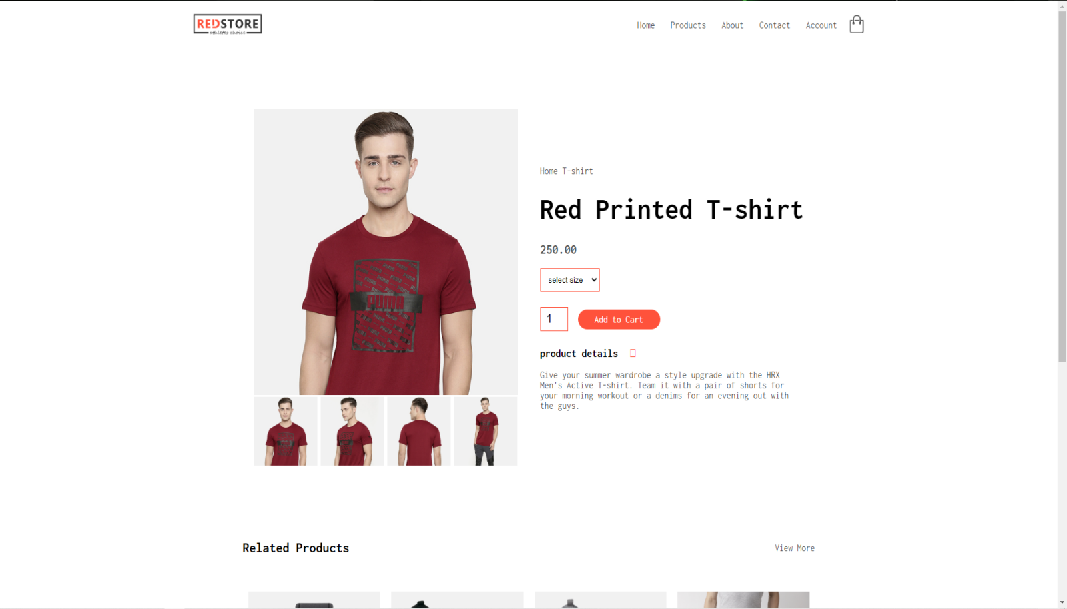

**HTML code:**

<div class="container">

<div class="navbar">

<div class="logo">

<img src="images/logo.png" width="125px" >

</div>

<nav>

<ul id="MenuItems">

<li><a href="home.html">Home</a></li>

<li><a href="products.html">Products</a></li>

<li><a href="">About</a></li>

<li><a href="">Contact</a></li>

<li><a href="account.html">Account</a></li>

</ul>

</nav>

<a href="cart.html"><img src="images/cart.png" width="30px" height="30px"></a>

<img src="images/menu.png" class="menu-icon" onclick="menutoggle()">

</div>

</div>

<!--single product details-->

<div class="small-container single-product">

<div class="row">

<div class="col-2">

<img src="images/gallery-1.jpg" width="100%" id="ProductImg">

<div class="small-img-row">

<div class="small-img-col">

<img src="images/gallery-1.jpg" width="100%" class="small-img">

</div>

<div class="small-img-col">

<img src="images/gallery-2.jpg" width="100%" class="small-img">

</div>

<div class="small-img-col">

<img src="images/gallery-3.jpg" width="100%" class="small-img">

</div>

<div class="small-img-col">

<img src="images/gallery-4.jpg" width="100%" class="small-img">

</div>

</div>

</div>

<div class="col-2">

<p>Home T-shirt</p>

<h1>Red Printed T-shirt</h1>

<h4>250.00</h4>

<select>

<option>select size</option>

<option>XXL</option>

<option>XL</option>

<option>L</option>

<option>M</option>

<option>S</option>

</select>

<input type="number" value="1">

<a href="cart.html" class="btn">Add to Cart</a>

<h3>product details <i class="fa fa-indent"></i></h3><br>

<p>Give your summer wardrobe a style upgrade with the HRX Men's Active T-shirt. Team it with a pair of shorts for your morning workout or a denims for an evening out with the guys.</p>

</div>

</div>

</div>

<!--title-->

<div class="small-container">

<div class="row row-2">

<h2>Related Products</h2>

<p>View More</p>

</div>

</div>

**JavaScript code:**

<script>

var ProductImg = document.getElementById("ProductImg");

var SmallImg = document.getElementsByClassName("small-img");

SmallImg[0].onclick = function(){

ProductImg.src = SmallImg[0].src;

}

SmallImg[1].onclick = function(){

ProductImg.src = SmallImg[1].src;

}

SmallImg[2].onclick = function(){

ProductImg.src = SmallImg[2].src;

}

SmallImg[3].onclick = function(){

ProductImg.src = SmallImg[3].src;

}

</script>

**Related products**

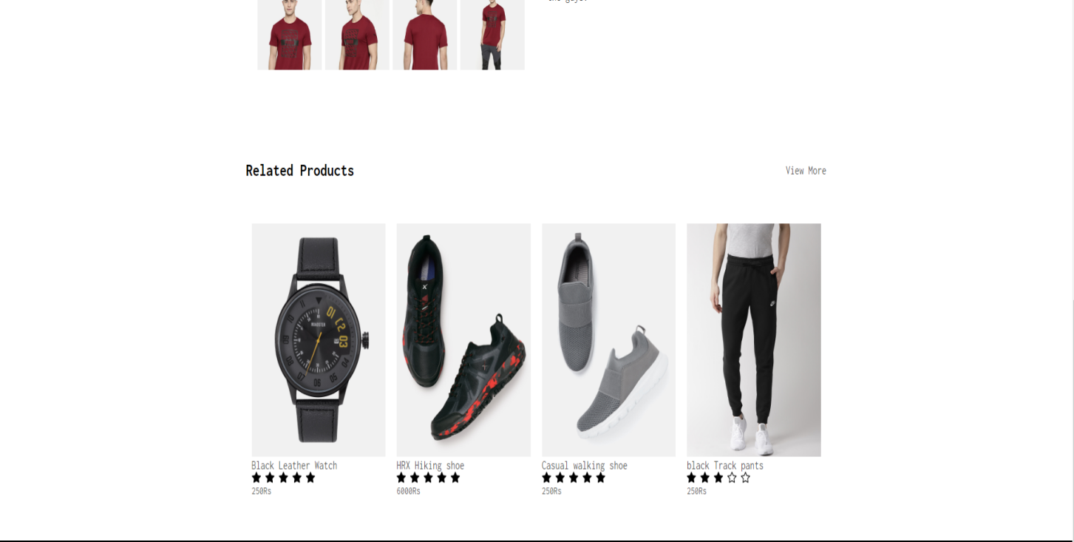

**HTML code:**

<div class="small-container">

<div class="row row-2">

<h2>Related Products</h2>

<p>View More</p>

</div>

</div>

<!--products-->

<div class="small-container">

<div class="row">

<div class="col-4">

<img src="images/product-9.jpg">

<h4>Black Leather Watch</h4>

<div class="rating">

<svg xmlns="http://www.w3.org/2000/svg" width="16" height="16" fill="currentColor" class="bi bi-star-fill" viewBox="0 0 16 16">

<path d="M3.612 15.443c-.386.198-.824-.149-.746-.592l.83-4.73L.173 6.765c-.329-.314-.158-.888.283-.95l4.898-.696L7.538.792c.197-.39.73-.39.927 0l2.184 4.327 4.898.696c.441.062.612.636.282.95l-3.522 3.356.83 4.73c.078.443-.36.79-.746.592L8 13.187l-4.389 2.256z"/>

</svg>

<svg xmlns="http://www.w3.org/2000/svg" width="16" height="16" fill="currentColor" class="bi bi-star-fill" viewBox="0 0 16 16">

<path d="M3.612 15.443c-.386.198-.824-.149-.746-.592l.83-4.73L.173 6.765c-.329-.314-.158-.888.283-.95l4.898-.696L7.538.792c.197-.39.73-.39.927 0l2.184 4.327 4.898.696c.441.062.612.636.282.95l-3.522 3.356.83 4.73c.078.443-.36.79-.746.592L8 13.187l-4.389 2.256z"/>

</svg>

<svg xmlns="http://www.w3.org/2000/svg" width="16" height="16" fill="currentColor" class="bi bi-star-fill" viewBox="0 0 16 16">

<path d="M3.612 15.443c-.386.198-.824-.149-.746-.592l.83-4.73L.173 6.765c-.329-.314-.158-.888.283-.95l4.898-.696L7.538.792c.197-.39.73-.39.927 0l2.184 4.327 4.898.696c.441.062.612.636.282.95l-3.522 3.356.83 4.73c.078.443-.36.79-.746.592L8 13.187l-4.389 2.256z"/>

</svg>

<svg xmlns="http://www.w3.org/2000/svg" width="16" height="16" fill="currentColor" class="bi bi-star-fill" viewBox="0 0 16 16">

<path d="M3.612 15.443c-.386.198-.824-.149-.746-.592l.83-4.73L.173 6.765c-.329-.314-.158-.888.283-.95l4.898-.696L7.538.792c.197-.39.73-.39.927 0l2.184 4.327 4.898.696c.441.062.612.636.282.95l-3.522 3.356.83 4.73c.078.443-.36.79-.746.592L8 13.187l-4.389 2.256z"/>

</svg>

<svg xmlns="http://www.w3.org/2000/svg" width="16" height="16" fill="currentColor" class="bi bi-star-fill" viewBox="0 0 16 16">

<path d="M3.612 15.443c-.386.198-.824-.149-.746-.592l.83-4.73L.173 6.765c-.329-.314-.158-.888.283-.95l4.898-.696L7.538.792c.197-.39.73-.39.927 0l2.184 4.327 4.898.696c.441.062.612.636.282.95l-3.522 3.356.83 4.73c.078.443-.36.79-.746.592L8 13.187l-4.389 2.256z"/>

</svg>

</div>

<p>250Rs</p>

</div>

<div class="col-4">

<img src="images/product-10.jpg">

<h4>HRX Hiking shoe</h4>

<div class="rating">

<svg xmlns="http://www.w3.org/2000/svg" width="16" height="16" fill="currentColor" class="bi bi-star-fill" viewBox="0 0 16 16">

<path d="M3.612 15.443c-.386.198-.824-.149-.746-.592l.83-4.73L.173 6.765c-.329-.314-.158-.888.283-.95l4.898-.696L7.538.792c.197-.39.73-.39.927 0l2.184 4.327 4.898.696c.441.062.612.636.282.95l-3.522 3.356.83 4.73c.078.443-.36.79-.746.592L8 13.187l-4.389 2.256z"/>

</svg>

<svg xmlns="http://www.w3.org/2000/svg" width="16" height="16" fill="currentColor" class="bi bi-star-fill" viewBox="0 0 16 16">

<path d="M3.612 15.443c-.386.198-.824-.149-.746-.592l.83-4.73L.173 6.765c-.329-.314-.158-.888.283-.95l4.898-.696L7.538.792c.197-.39.73-.39.927 0l2.184 4.327 4.898.696c.441.062.612.636.282.95l-3.522 3.356.83 4.73c.078.443-.36.79-.746.592L8 13.187l-4.389 2.256z"/>

</svg>

<svg xmlns="http://www.w3.org/2000/svg" width="16" height="16" fill="currentColor" class="bi bi-star-fill" viewBox="0 0 16 16">

<path d="M3.612 15.443c-.386.198-.824-.149-.746-.592l.83-4.73L.173 6.765c-.329-.314-.158-.888.283-.95l4.898-.696L7.538.792c.197-.39.73-.39.927 0l2.184 4.327 4.898.696c.441.062.612.636.282.95l-3.522 3.356.83 4.73c.078.443-.36.79-.746.592L8 13.187l-4.389 2.256z"/>

</svg>

<svg xmlns="http://www.w3.org/2000/svg" width="16" height="16" fill="currentColor" class="bi bi-star-fill" viewBox="0 0 16 16">

<path d="M3.612 15.443c-.386.198-.824-.149-.746-.592l.83-4.73L.173 6.765c-.329-.314-.158-.888.283-.95l4.898-.696L7.538.792c.197-.39.73-.39.927 0l2.184 4.327 4.898.696c.441.062.612.636.282.95l-3.522 3.356.83 4.73c.078.443-.36.79-.746.592L8 13.187l-4.389 2.256z"/>

</svg>

<svg xmlns="http://www.w3.org/2000/svg" width="16" height="16" fill="currentColor" class="bi bi-star-fill" viewBox="0 0 16 16">

<path d="M3.612 15.443c-.386.198-.824-.149-.746-.592l.83-4.73L.173 6.765c-.329-.314-.158-.888.283-.95l4.898-.696L7.538.792c.197-.39.73-.39.927 0l2.184 4.327 4.898.696c.441.062.612.636.282.95l-3.522 3.356.83 4.73c.078.443-.36.79-.746.592L8 13.187l-4.389 2.256z"/>

</svg>

</div>

<p>6000Rs</p>

</div>

<div class="col-4">

<img src="images/product-11.jpg">

<h4>Casual walking shoe</h4>

<div class="rating">

<svg xmlns="http://www.w3.org/2000/svg" width="16" height="16" fill="currentColor" class="bi bi-star-fill" viewBox="0 0 16 16">

<path d="M3.612 15.443c-.386.198-.824-.149-.746-.592l.83-4.73L.173 6.765c-.329-.314-.158-.888.283-.95l4.898-.696L7.538.792c.197-.39.73-.39.927 0l2.184 4.327 4.898.696c.441.062.612.636.282.95l-3.522 3.356.83 4.73c.078.443-.36.79-.746.592L8 13.187l-4.389 2.256z"/>

</svg>

<svg xmlns="http://www.w3.org/2000/svg" width="16" height="16" fill="currentColor" class="bi bi-star-fill" viewBox="0 0 16 16">

<path d="M3.612 15.443c-.386.198-.824-.149-.746-.592l.83-4.73L.173 6.765c-.329-.314-.158-.888.283-.95l4.898-.696L7.538.792c.197-.39.73-.39.927 0l2.184 4.327 4.898.696c.441.062.612.636.282.95l-3.522 3.356.83 4.73c.078.443-.36.79-.746.592L8 13.187l-4.389 2.256z"/>

</svg>

<svg xmlns="http://www.w3.org/2000/svg" width="16" height="16" fill="currentColor" class="bi bi-star-fill" viewBox="0 0 16 16">

<path d="M3.612 15.443c-.386.198-.824-.149-.746-.592l.83-4.73L.173 6.765c-.329-.314-.158-.888.283-.95l4.898-.696L7.538.792c.197-.39.73-.39.927 0l2.184 4.327 4.898.696c.441.062.612.636.282.95l-3.522 3.356.83 4.73c.078.443-.36.79-.746.592L8 13.187l-4.389 2.256z"/>

</svg>

<svg xmlns="http://www.w3.org/2000/svg" width="16" height="16" fill="currentColor" class="bi bi-star-fill" viewBox="0 0 16 16">

<path d="M3.612 15.443c-.386.198-.824-.149-.746-.592l.83-4.73L.173 6.765c-.329-.314-.158-.888.283-.95l4.898-.696L7.538.792c.197-.39.73-.39.927 0l2.184 4.327 4.898.696c.441.062.612.636.282.95l-3.522 3.356.83 4.73c.078.443-.36.79-.746.592L8 13.187l-4.389 2.256z"/>

</svg>

<svg xmlns="http://www.w3.org/2000/svg" width="16" height="16" fill="currentColor" class="bi bi-star-fill" viewBox="0 0 16 16">

<path d="M3.612 15.443c-.386.198-.824-.149-.746-.592l.83-4.73L.173 6.765c-.329-.314-.158-.888.283-.95l4.898-.696L7.538.792c.197-.39.73-.39.927 0l2.184 4.327 4.898.696c.441.062.612.636.282.95l-3.522 3.356.83 4.73c.078.443-.36.79-.746.592L8 13.187l-4.389 2.256z"/>

</svg>

</div>

<p>250Rs</p>

</div>

<div class="col-4">

<img src="images/product-12.jpg">

<h4>black Track pants</h4>

<div class="rating">

<svg xmlns="http://www.w3.org/2000/svg" width="16" height="16" fill="currentColor" class="bi bi-star-fill" viewBox="0 0 16 16">

<path d="M3.612 15.443c-.386.198-.824-.149-.746-.592l.83-4.73L.173 6.765c-.329-.314-.158-.888.283-.95l4.898-.696L7.538.792c.197-.39.73-.39.927 0l2.184 4.327 4.898.696c.441.062.612.636.282.95l-3.522 3.356.83 4.73c.078.443-.36.79-.746.592L8 13.187l-4.389 2.256z"/>

</svg>

<svg xmlns="http://www.w3.org/2000/svg" width="16" height="16" fill="currentColor" class="bi bi-star-fill" viewBox="0 0 16 16">

<path d="M3.612 15.443c-.386.198-.824-.149-.746-.592l.83-4.73L.173 6.765c-.329-.314-.158-.888.283-.95l4.898-.696L7.538.792c.197-.39.73-.39.927 0l2.184 4.327 4.898.696c.441.062.612.636.282.95l-3.522 3.356.83 4.73c.078.443-.36.79-.746.592L8 13.187l-4.389 2.256z"/>

</svg>

<svg xmlns="http://www.w3.org/2000/svg" width="16" height="16" fill="currentColor" class="bi bi-star-fill" viewBox="0 0 16 16">

<path d="M3.612 15.443c-.386.198-.824-.149-.746-.592l.83-4.73L.173 6.765c-.329-.314-.158-.888.283-.95l4.898-.696L7.538.792c.197-.39.73-.39.927 0l2.184 4.327 4.898.696c.441.062.612.636.282.95l-3.522 3.356.83 4.73c.078.443-.36.79-.746.592L8 13.187l-4.389 2.256z"/>

</svg>

<svg xmlns="http://www.w3.org/2000/svg" width="16" height="16" fill="currentColor" class="bi bi-star" viewBox="0 0 16 16">

<path d="M2.866 14.85c-.078.444.36.791.746.593l4.39-2.256 4.389 2.256c.386.198.824-.149.746-.592l-.83-4.73 3.522-3.356c.33-.314.16-.888-.282-.95l-4.898-.696L8.465.792a.513.513 0 0 0-.927 0L5.354 5.12l-4.898.696c-.441.062-.612.636-.283.95l3.523 3.356-.83 4.73zm4.905-2.767-3.686 1.894.694-3.957a.565.565 0 0 0-.163-.505L1.71 6.745l4.052-.576a.525.525 0 0 0 .393-.288L8 2.223l1.847 3.658a.525.525 0 0 0 .393.288l4.052.575-2.906 2.77a.565.565 0 0 0-.163.506l.694 3.957-3.686-1.894a.503.503 0 0 0-.461 0z"/>

</svg>

<svg xmlns="http://www.w3.org/2000/svg" width="16" height="16" fill="currentColor" class="bi bi-star" viewBox="0 0 16 16">

<path d="M2.866 14.85c-.078.444.36.791.746.593l4.39-2.256 4.389 2.256c.386.198.824-.149.746-.592l-.83-4.73 3.522-3.356c.33-.314.16-.888-.282-.95l-4.898-.696L8.465.792a.513.513 0 0 0-.927 0L5.354 5.12l-4.898.696c-.441.062-.612.636-.283.95l3.523 3.356-.83 4.73zm4.905-2.767-3.686 1.894.694-3.957a.565.565 0 0 0-.163-.505L1.71 6.745l4.052-.576a.525.525 0 0 0 .393-.288L8 2.223l1.847 3.658a.525.525 0 0 0 .393.288l4.052.575-2.906 2.77a.565.565 0 0 0-.163.506l.694 3.957-3.686-1.894a.503.503 0 0 0-.461 0z"/>

</svg>

</div>

<p>250Rs</p>

</div>

</div>

</div>

**Footer:**



**HTML code:**

<!--footer-->

<div class="footer">

<div class="container">

<div class="row">

<div class="footer-col-1">

<h3>Download</h3>

<p>For android and ios</p>

<div class="app-logo">

<img src="images/play-store.png">

<img src="images/app-store.png">

</div>

</div>

<div class="footer-col-2">

<img src="images/logo-white.png">

<p>For android and ios</p>

</div>

<div class="footer-col-3">

<h3>Useful Links</h3>

<ul>

<li>Coupons</li>

<li>Blog Post</li>

<li>Return Policy</li>

<li>Join Affiliate</li>

</ul>

</div>

<div class="footer-col-4">

<h3>Follow Us</h3>

<ul>

<li>Facebook</li>

<li>Twitter</li>

<li>Instagram</li>

<li>YouTube</li>

</ul>

</div>

</div>

<hr>

<p class="copyright">All claims to the owner</p>

</div>

</div>

**CSS code:**

.footer{

background: #000;

color: #8a8a8a;

font-size: 14px;

padding: 60px 0 20px;

}

.footer p{

color: #8a8a8a;

}

.footer h3{

color: #fff;

margin-bottom: 20px;

}

.footer-col-1, .footer-col-2, .footer-col-3, .footer-col-4{

min-width: 250px;

margin-bottom: 20px;

}

.footer-col-1{

flex-basis: 30%;

}

.footer-col-2{

flex: 1;

text-align: center;

}

.footer-col-2 img{

width: 180px;

margin-bottom: 20px;

}

.footer-col-3, .footer-col-4{

flex-basis: 12%;

text-align: center;

}

ul{

list-style-type: none;

}

.app-logo{

margin-top: 20px;

}

.app-logo img{

width: 140px;

}

.footer hr{

border: none;

background: #b5b5b5;

height: 1px;

margin: 20px 0;

}

.copyright{

text-align: center;

}

.menu-icon{

width: 28px;

margin-left: 20px;

display: none;

}

**JavaScript :**

<script>

var MenuItems = document.getElementById("MenuItems");

MenuItems.style.maxHeight = "0px";

function menutoggle(){

if(MenuItems.style.maxHeight == "0px"){

MenuItems.style.maxHeight = "200px";

}

else

{

MenuItems.style.maxHeight = "0px";

}

}

</script>

**CART**

**Head:**

<!DOCTYPE html>

<html lang="en">

<head>

<meta charset="UTF-8">

<meta name="viewport" content="width=device-width, initial-scale=1.0">

<meta http-equiv="X-UA-Compatible" content="IE=edge">

<meta name="viewport" content="width=device-width, initial-scale=1.0">

<title>All Products</title>

<link rel="stylesheet" href="style.css">

<link rel="preconnect" href="https://fonts.googleapis.com">

<link rel="preconnect" href="https://fonts.gstatic.com" crossorigin>

<link href="https://fonts.googleapis.com/css2?family=Inconsolata:wght@300;400;500;600;700&display=swap" rel="stylesheet">

<link rel="stylesheet" href="https://cdn.jsdelivr.net/npm/@fortawesome/fontawesome-free@6.1.1/css/fontawesome.min.css" integrity="sha384-zIaWifL2YFF1qaDiAo0JFgsmasocJ/rqu7LKYH8CoBEXqGbb9eO+Xi3s6fQhgFWM" crossorigin="anonymous">

</head>

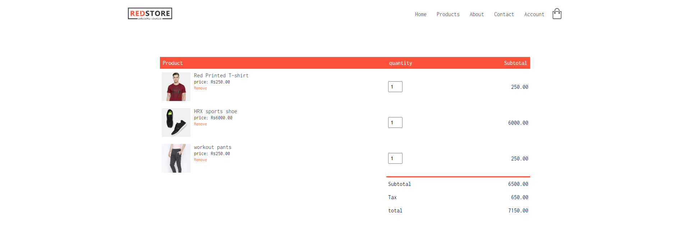

**HTML code:**

<div class="container">

<div class="navbar">

<div class="logo">

<img src="images/logo.png" width="125px" >

</div>

<nav>

<ul id="MenuItems">

<li><a href="home.html">Home</a></li>

<li><a href="products.html">Products</a></li>

<li><a href="">About</a></li>

<li><a href="">Contact</a></li>

<li><a href="account.html">Account</a></li>

</ul>

</nav>

<a href="cart.html"><img src="images/cart.png" width="30px" height="30px"></a>

<img src="images/menu.png" class="menu-icon" onclick="menutoggle()">

</div>

</div>

<!--cart item details-->

<div class="small-container cart-page">

<table>

<tr>

<th>Product</th>

<th>quantity</th>

<th>Subtotal</th>

</tr>

<tr>

<td>

<div class="cart-info">

<img src="images/buy-1.jpg">

<div>

<p>Red Printed T-shirt</p>

<small>price: Rs250.00</small><br>

<a href="">Remove</a>

</div>

</div>

</td>

<td><input type="number" value="1"></td>

<td>250.00</td>

</tr>

<tr>

<td>

<div class="cart-info">

<img src="images/buy-2.jpg">

<div>

<p>HRX sports shoe</p>

<small>price: Rs6000.00</small><br>

<a href="">Remove</a>

</div>

</div>

</td>

<td><input type="number" value="1"></td>

<td>6000.00</td>

</tr>

<tr>

<td>

<div class="cart-info">

<img src="images/buy-3.jpg">

<div>

<p>workout pants</p>

<small>price: Rs250.00</small><br>

<a href="">Remove</a>

</div>

</div>

</td>

<td><input type="number" value="1"></td>

<td>250.00</td>

</tr>

</table>

<div class="total-price">

<table>

<tr>

<td>Subtotal</td>

<td>6500.00</td>

</tr>

<tr>

<td>Tax</td>

<td>650.00</td>

</tr>

<tr>

<td>total</td>

<td>7150.00</td>

</tr>

</table>

</div>

</div>

**Footer:**



**HTML code:**

<!--footer-->

<div class="footer">

<div class="container">

<div class="row">

<div class="footer-col-1">

<h3>Download</h3>

<p>For android and ios</p>

<div class="app-logo">

<img src="images/play-store.png">

<img src="images/app-store.png">

</div>

</div>

<div class="footer-col-2">

<img src="images/logo-white.png">

<p>For android and ios</p>

</div>

<div class="footer-col-3">

<h3>Useful Links</h3>

<ul>

<li>Coupons</li>

<li>Blog Post</li>

<li>Return Policy</li>

<li>Join Affiliate</li>

</ul>

</div>

<div class="footer-col-4">

<h3>Follow Us</h3>

<ul>

<li>Facebook</li>

<li>Twitter</li>

<li>Instagram</li>

<li>YouTube</li>

</ul>

</div>

</div>

<hr>

<p class="copyright">All claims to the owner</p>

</div>

</div>

**CSS code:**

.footer{

background: #000;

color: #8a8a8a;

font-size: 14px;

padding: 60px 0 20px;

}

.footer p{

color: #8a8a8a;

}

.footer h3{

color: #fff;

margin-bottom: 20px;

}

.footer-col-1, .footer-col-2, .footer-col-3, .footer-col-4{

min-width: 250px;

margin-bottom: 20px;

}

.footer-col-1{

flex-basis: 30%;

}

.footer-col-2{

flex: 1;

text-align: center;

}

.footer-col-2 img{

width: 180px;

margin-bottom: 20px;

}

.footer-col-3, .footer-col-4{

flex-basis: 12%;

text-align: center;

}

ul{

list-style-type: none;

}

.app-logo{

margin-top: 20px;

}

.app-logo img{

width: 140px;

}

.footer hr{

border: none;

background: #b5b5b5;

height: 1px;

margin: 20px 0;

}

.copyright{

text-align: center;

}

.menu-icon{

width: 28px;

margin-left: 20px;

display: none;

}

**JavaScript:**

<script>

var MenuItems = document.getElementById("MenuItems");

MenuItems.style.maxHeight = "0px";

function menutoggle(){

if(MenuItems.style.maxHeight == "0px"){

MenuItems.style.maxHeight = "200px";

}

else

{

MenuItems.style.maxHeight = "0px";

}

}

</script>

**LOGIN/SIGN-UP PAGE**

**Head:**

<!DOCTYPE html>

<html lang="en">

<head>

<meta charset="UTF-8">

<meta name="viewport" content="width=device-width, initial-scale=1.0">

<meta http-equiv="X-UA-Compatible" content="IE=edge">

<meta name="viewport" content="width=device-width, initial-scale=1.0">

<title>All Products</title>

<link rel="stylesheet" href="style.css">

<link rel="preconnect" href="https://fonts.googleapis.com">

<link rel="preconnect" href="https://fonts.gstatic.com" crossorigin>

<link href="https://fonts.googleapis.com/css2?family=Inconsolata:wght@300;400;500;600;700&display=swap" rel="stylesheet">

<link rel="stylesheet" href="https://cdn.jsdelivr.net/npm/@fortawesome/fontawesome-free@6.1.1/css/fontawesome.min.css" integrity="sha384-zIaWifL2YFF1qaDiAo0JFgsmasocJ/rqu7LKYH8CoBEXqGbb9eO+Xi3s6fQhgFWM" crossorigin="anonymous">

</head>

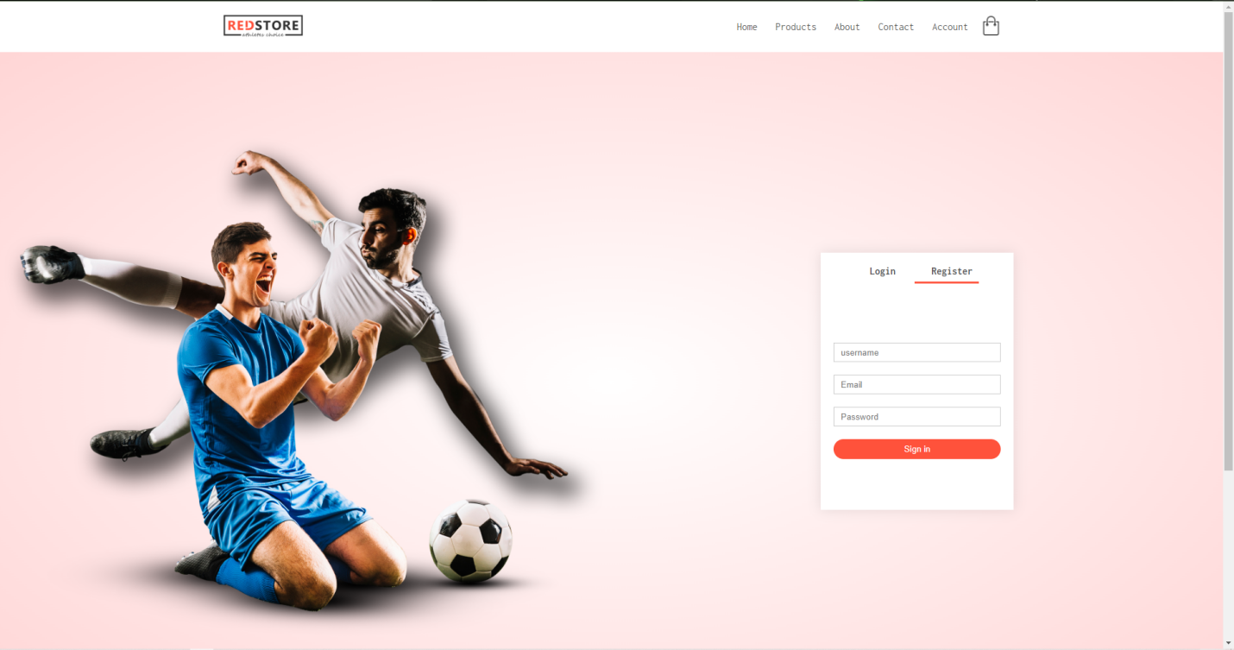

**HTML code:**

<div class="container">

<div class="navbar">

<div class="logo">

<img src="images/logo.png" width="125px" >

</div>

<nav>

<ul id="MenuItems">

<li><a href="home.html">Home</a></li>

<li><a href="products.html">Products</a></li>

<li><a href="">About</a></li>

<li><a href="">Contact</a></li>

<li><a href="account.html">Account</a></li>

</ul>

</nav>

<a href="cart.html"><img src="images/cart.png" width="30px" height="30px"></a>

<img src="images/menu.png" class="menu-icon" onclick="menutoggle()">

</div>

</div>

<!--account-page-->

<div class="account-page">

<div class="contaier">

<div class="row">

<div class="col-2">

<img src="images/image1.png" width="100%">

</div>

<div class="col-2">

<div class="form-container">

<div class="form-btn">

<span onclick="login()">Login</span>

<span onclick="register()">Register</span>

<hr id="Indicator">

</div>

<form id="LoginForm">

<input type="Text" placeholder="username">

<input type= "Password"placeholder="Password">

<button type="submit" class="btn">Login</button>

<a href="">Forgot Password</a>

</form>

<form id="RegForm">

<input type="Text" placeholder="username">

<input type="email" placeholder="Email">

<input type= "Password"placeholder="Password">

<button type="submit" class="btn">Sign in</button>

</form>

</div>

</div>

</div>

</div>

</div>

**JavaScript:**

<script>

var MenuItems = document.getElementById("MenuItems");

MenuItems.style.maxHeight = "0px";

function menutoggle(){

if(MenuItems.style.maxHeight == "0px"){

MenuItems.style.maxHeight = "200px";

}

else

{

MenuItems.style.maxHeight = "0px";

}

}

</script>

<!--js for toggle-->

<script>

var LoginForm = document.getElementById("LoginForm");

var RegForm = document.getElementById("RegForm");

var Indicator = Document.getElementById("Indicator");

function register(){

RegForm.style.transform = "translateX(0px)";

LoginForm.style.transform = "translateX(0px)";

Indicator.style.transform = "translateX(100px)";

}

function login(){

RegForm.style.transform = "translateX(300px)";

LoginForm.style.transform = "translateX(300px)";

Indicator.style.transform = "translateX(0px)";

}

</script>

**Footer section:**



**HTML code:**

<!--footer-->

<div class="footer">

<div class="container">

<div class="row">

<div class="footer-col-1">

<h3>Download</h3>

<p>For android and ios</p>

<div class="app-logo">

<img src="images/play-store.png">

<img src="images/app-store.png">

</div>

</div>

<div class="footer-col-2">

<img src="images/logo-white.png">

<p>For android and ios</p>

</div>

<div class="footer-col-3">

<h3>Useful Links</h3>

<ul>

<li>Coupons</li>

<li>Blog Post</li>

<li>Return Policy</li>

<li>Join Affiliate</li>

</ul>

</div>

<div class="footer-col-4">

<h3>Follow Us</h3>

<ul>

<li>Facebook</li>

<li>Twitter</li>

<li>Instagram</li>

<li>YouTube</li>

</ul>

</div>

</div>

<hr>

<p class="copyright">All claims to the owner</p>

</div>

</div>

**LOGIN PHP:**

Login Page

<!doctype html>

<html lang="en">

<head>

<!-- Required meta tags -->

<meta charset="utf-8">

<meta name="viewport" content="width=device-width, initial-scale=1, shrink-to-fit=no">

<!-- Bootstrap CSS -->

<link rel="stylesheet" href="https://stackpath.bootstrapcdn.com/bootstrap/4.3.1/css/bootstrap.min.css" integrity="sha384-ggOyR0iXCbMQv3Xipma34MD+dH/1fQ784/j6cY/iJTQUOhcWr7x9JvoRxT2MZw1T" crossorigin="anonymous">

<title>PHP login system!</title>

</head>

<body>

<nav class="navbar navbar-expand-lg navbar-dark bg-dark">

<a class="navbar-brand" href="#">Php Login System</a>

<button class="navbar-toggler" type="button" data-toggle="collapse" data-target="#navbarNavDropdown" aria-controls="navbarNavDropdown" aria-expanded="false" aria-label="Toggle navigation">

<span class="navbar-toggler-icon"></span>

</button>

<div class="collapse navbar-collapse" id="navbarNavDropdown">

<ul class="navbar-nav">

<li class="nav-item active">

<a class="nav-link" href="#">Home <span class="sr-only">(current)</span></a>

</li>

<li class="nav-item">

<a class="nav-link" href="register.php">Register</a>

</li>

<li class="nav-item">

<a class="nav-link" href="login.php">Login</a>

</li>

<li class="nav-item">

<a class="nav-link" href="logout.php">Logout</a>

</li>

</ul>

</div>

</nav>

<div class="container mt-4">

<h3>Please Login Here:</h3>

<hr>

<form action="" method="post">

<div class="form-group">

<label for="exampleInputEmail1">Username</label>

<input type="text" name="username" class="form-control" id="exampleInputEmail1" aria-describedby="emailHelp" placeholder="Enter Username">

</div>

<div class="form-group">

<label for="exampleInputPassword1">Password</label>

<input type="password" name="password" class="form-control" id="exampleInputPassword1" placeholder="Enter Password">

</div>

<div class="form-group form-check">

<input type="checkbox" class="form-check-input" id="exampleCheck1">

<label class="form-check-label" for="exampleCheck1">Check me out</label>

</div>

<button type="submit" class="btn btn-primary">Submit</button>

</form>

</div>

<!-- Optional JavaScript -->

<!-- jQuery first, then Popper.js, then Bootstrap JS -->

<script src="https://code.jquery.com/jquery-3.3.1.slim.min.js" integrity="sha384-q8i/X+965DzO0rT7abK41JStQIAqVgRVzpbzo5smXKp4YfRvH+8abtTE1Pi6jizo" crossorigin="anonymous"></script>

<script src="https://cdnjs.cloudflare.com/ajax/libs/popper.js/1.14.7/umd/popper.min.js" integrity="sha384-UO2eT0CpHqdSJQ6hJty5KVphtPhzWj9WO1clHTMGa3JDZwrnQq4sF86dIHNDz0W1" crossorigin="anonymous"></script>

<script src="https://stackpath.bootstrapcdn.com/bootstrap/4.3.1/js/bootstrap.min.js" integrity="sha384-JjSmVgyd0p3pXB1rRibZUAYoIIy6OrQ6VrjIEaFf/nJGzIxFDsf4x0xIM+B07jRM" crossorigin="anonymous"></script>

</body>

</html>

**REGISTER PHP:**

<!doctype html>

<html lang="en">

<head>

<!-- Required meta tags -->

<meta charset="utf-8">

<meta name="viewport" content="width=device-width, initial-scale=1, shrink-to-fit=no">

<!-- Bootstrap CSS -->

<link rel="stylesheet" href="https://stackpath.bootstrapcdn.com/bootstrap/4.3.1/css/bootstrap.min.css" integrity="sha384-ggOyR0iXCbMQv3Xipma34MD+dH/1fQ784/j6cY/iJTQUOhcWr7x9JvoRxT2MZw1T" crossorigin="anonymous">

<title>PHP login system!</title>

</head>

<body>

<nav class="navbar navbar-expand-lg navbar-dark bg-dark">

<a class="navbar-brand" href="#">Php Login System</a>

<button class="navbar-toggler" type="button" data-toggle="collapse" data-target="#navbarNavDropdown" aria-controls="navbarNavDropdown" aria-expanded="false" aria-label="Toggle navigation">

<span class="navbar-toggler-icon"></span>

</button>

<div class="collapse navbar-collapse" id="navbarNavDropdown">

<ul class="navbar-nav">

<li class="nav-item active">

<a class="nav-link" href="#">Home <span class="sr-only">(current)</span></a>

</li>

<li class="nav-item">

<a class="nav-link" href="register.php">Register</a>

</li>

<li class="nav-item">

<a class="nav-link" href="login.php">Login</a>

</li>

<li class="nav-item">

<a class="nav-link" href="logout.php">Logout</a>

</li>

</ul>

</div>

</nav>

<div class="container mt-4">

<h3>Please Register Here:</h3>

<hr>

<form action="" method="post">

<div class="form-row">

<div class="form-group col-md-6">

<label for="inputEmail4">Username</label>

<input type="text" class="form-control" name="username" id="inputEmail4" placeholder="Email">

</div>

<div class="form-group col-md-6">

<label for="inputPassword4">Password</label>

<input type="password" class="form-control" name ="password" id="inputPassword4" placeholder="Password">

</div>

</div>

<div class="form-group">

<label for="inputPassword4">Confirm Password</label>

<input type="password" class="form-control" name ="confirm_password" id="inputPassword" placeholder="Confirm Password">

</div>

<div class="form-group">

<label for="inputAddress2">Address 2</label>

<input type="text" class="form-control" id="inputAddress2" placeholder="Apartment, studio, or floor">

</div>

<div class="form-row">

<div class="form-group col-md-6">

<label for="inputCity">City</label>

<input type="text" class="form-control" id="inputCity">

</div>

<div class="form-group col-md-4">

<label for="inputState">State</label>

<select id="inputState" class="form-control">

<option selected>Choose...</option>

<option>...</option>

</select>

</div>

<div class="form-group col-md-2">

<label for="inputZip">Zip</label>

<input type="text" class="form-control" id="inputZip">

</div>

</div>

<div class="form-group">

<div class="form-check">

<input class="form-check-input" type="checkbox" id="gridCheck">

<label class="form-check-label" for="gridCheck">

Check me out

</label>

</div>

</div>

<button type="submit" class="btn btn-primary">Sign in</button>

</form>

</div>

<!-- Optional JavaScript -->

<!-- jQuery first, then Popper.js, then Bootstrap JS -->

<script src="https://code.jquery.com/jquery-3.3.1.slim.min.js" integrity="sha384-q8i/X+965DzO0rT7abK41JStQIAqVgRVzpbzo5smXKp4YfRvH+8abtTE1Pi6jizo" crossorigin="anonymous"></script>

<script src="https://cdnjs.cloudflare.com/ajax/libs/popper.js/1.14.7/umd/popper.min.js" integrity="sha384-UO2eT0CpHqdSJQ6hJty5KVphtPhzWj9WO1clHTMGa3JDZwrnQq4sF86dIHNDz0W1" crossorigin="anonymous"></script>

<script src="https://stackpath.bootstrapcdn.com/bootstrap/4.3.1/js/bootstrap.min.js" integrity="sha384-JjSmVgyd0p3pXB1rRibZUAYoIIy6OrQ6VrjIEaFf/nJGzIxFDsf4x0xIM+B07jRM" crossorigin="anonymous"></script>

</body>

</html>

Welcome Page

<!doctype html>

<html lang="en">

<head>

<!-- Required meta tags -->

<meta charset="utf-8">

<meta name="viewport" content="width=device-width, initial-scale=1, shrink-to-fit=no">

<!-- Bootstrap CSS -->

<link rel="stylesheet" href="https://stackpath.bootstrapcdn.com/bootstrap/4.3.1/css/bootstrap.min.css" integrity="sha384-ggOyR0iXCbMQv3Xipma34MD+dH/1fQ784/j6cY/iJTQUOhcWr7x9JvoRxT2MZw1T" crossorigin="anonymous">

<title>PHP login system!</title>

</head>

<body>

<nav class="navbar navbar-expand-lg navbar-dark bg-dark">

<a class="navbar-brand" href="#">Php Login System</a>

<button class="navbar-toggler" type="button" data-toggle="collapse" data-target="#navbarNavDropdown" aria-controls="navbarNavDropdown" aria-expanded="false" aria-label="Toggle navigation">

<span class="navbar-toggler-icon"></span>

</button>

<div class="collapse navbar-collapse" id="navbarNavDropdown">

<ul class="navbar-nav">

<li class="nav-item active">

<a class="nav-link" href="#">Home <span class="sr-only">(current)</span></a>

</li>

<li class="nav-item">

<a class="nav-link" href="register.php">Register</a>

</li>

<li class="nav-item">

<a class="nav-link" href="login.php">Login</a>

</li>

<li class="nav-item">

<a class="nav-link" href="logout.php">Logout</a>

</li>

</ul>

<div class="navbar-collapse collapse">

<ul class="navbar-nav ml-auto">

<li class="nav-item active">

<a class="nav-link" href="#"> <?php echo "Welcome ". $_SESSION['username']?></a>

</li>

</ul>

</div>

</div>

</nav>

<div class="container mt-4">

<h3><?php echo "Welcome ". $_SESSION['username']?>! You can now use this website</h3>

<hr>

</div>

<!-- Optional JavaScript -->

<!-- jQuery first, then Popper.js, then Bootstrap JS -->

<script src="https://code.jquery.com/jquery-3.3.1.slim.min.js" integrity="sha384-q8i/X+965DzO0rT7abK41JStQIAqVgRVzpbzo5smXKp4YfRvH+8abtTE1Pi6jizo" crossorigin="anonymous"></script>

<script src="https://cdnjs.cloudflare.com/ajax/libs/popper.js/1.14.7/umd/popper.min.js" integrity="sha384-UO2eT0CpHqdSJQ6hJty5KVphtPhzWj9WO1clHTMGa3JDZwrnQq4sF86dIHNDz0W1" crossorigin="anonymous"></script>

<script src="https://stackpath.bootstrapcdn.com/bootstrap/4.3.1/js/bootstrap.min.js" integrity="sha384-JjSmVgyd0p3pXB1rRibZUAYoIIy6OrQ6VrjIEaFf/nJGzIxFDsf4x0xIM+B07jRM" crossorigin="anonymous"></script>

</body>

</html>

**The CSS stylesheet for the whole project**